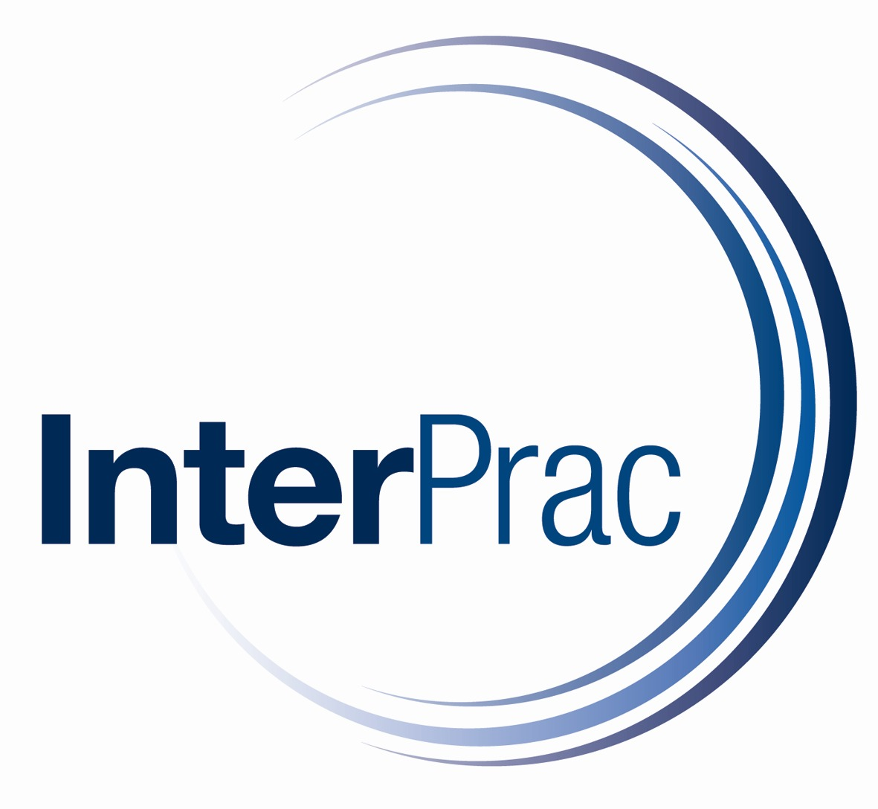 | InterPrac General Insurance Pty Ltd  ABN 70 127 114 541  Street Address: Shop 4  172-176 McIvor Road  Bendigo VIC 3550  Phone: 1800 086 666  Fax: 1300 161 756

InterPrac Tax Practice Audit Cover

Proposal Form

1. All questions must be answered giving full and complete answers.
2. Please ensure that this Proposal Form is Signed and Dated.
3. All fee or turnover declarations to be in Australian Dollars.

Your Contact Details
Name
Phone Number |  | Mobile Number
Email Address
Postal Address
Current Provider (if applicable) | Name : | Limit : | Expiry Date:

IMPORTANT NOTICES
“Proposer” means the practice, partnership, company (or principal if a sole practitioner) including all partners proposing for this insurance, and any subsidiaries and previous firms (and partners) requiring coverage.
For your protection under legislation, we are required to inform you of your duty of disclosure and draw your attention to the following important information.

FINANCIAL SERVICES GUIDE
We strongly recommend that you read our Financial Services Guide which can be obtained from our website – www.interprac.com.au
Your duty of disclosure
Before you enter into an insurance contract, you have a duty to tell us anything that you know, or could reasonably be expected to know, may affect our decision to insure you and on what terms.
You have this duty until we agree to insure you.
You have the same duty before you renew, extend, vary or reinstate an insurance contract.
You do not need to tell us anything that:
- reduces the risk we insure you for; or
- is common knowledge; or
- we know or should know as an insurer; or
- we waive your duty to tell us about.
If you do not tell us something
If you do not tell us anything you are required to, we may cancel your contract or reduce the amount we will pay you if you make a claim, or both.
If your failure to tell us is fraudulent, we may refuse to pay a claim and treat the contract as if it never existed.

NON-DISCLOSURE
If you do not tell us anything you are required to, we may cancel your contract or reduce the amount we will pay you if you make a claim or both .
If your failure to tell us is fraudulent, we may refuse to pay a claim and treat the contract as if it never existed.
Claims Made
This is a “claims made” policy of insurance, which means that it only covers claims made against an insured and notified to Underwriters during the period of insurance. By operation of Section 40 (3) of the Insurance Contracts Act 1984, where the insured gives notice in writing to the Underwriters of facts that might give rise to a claim against the insured as soon as was reasonably practicable after the insured became aware of those facts but before the insurance cover provided by the contract expired, the insurer is not relieved of liability under the contract in respect of any claim arising from those facts, when made, by reason only that it was made after the expiration of the period of the insurance cover provided by the contract.
Retroactive Liability
The policy may be limited by a retroactive date stated in the schedule. The policy does not provide cover in relation to any claim arising from any actual or alleged act, error, omission or conduct that occurs before the commencement of the policy, unless retroactive liability cover is extended by Underwriters.
DISPUTES
Clients not satisfied with our services should contact our Complaints Officer. We are members of the Financial Ombudsman Service (FOS), a free consumer service. Further information is available from our office, or contact FOS directly on 1300 780 808 or visit www.fos.org.au. We also follow the Insurance Brokers Code of Practice.
Liability Assumed Under Agreement
Cover provided by this form of liability insurance does not cover additional liability which you have agreed to accept unless you would have been so liable in the absence of such agreement.

UTMOST GOOD FAITH
Every contract of insurance is subject to the doctrine of utmost good faith which requires that the parties to the contract should act toward each other with the utmost good faith. Failure to do so on your part may prejudice any claim or the continuation of cover provided by Insurers.

UNDERWRITING AGENTS AND WHOLESALE BROKERS
In some cases we access insurance products via Underwriting Agents and Wholesale brokers rather than directly with the insurer. In such cases should you wish to access the Financial Services Guide of the Underwriting Agency or Wholesale Broker please contact us and we will arrange to have a copy sent out to you.

Privacy Notice
The Privacy Amendment (Private Sector) Act 2000 requires us to inform you that we collect, use and disclose your personal information. A copy of our Privacy Policy is available on request from our office.
TERMS OF TRADE
Payment of this account constitutes your acknowledgement and acceptance of these conditions and authorises us to act as your insurance brokers for the risks outlined on the face hereof and no others unless specifically agreed by us in writing

This is an application for a claims-made and reported policy. This policy provides cover for your Clients Costs of a Claim arising directly from either of the following:

- GST Audit undertaken by the ATO
- Fringe Benefits Audit undertaken by the ATO
- Income Tax Legislation audit or investigation undertaken by the ATO
- An audit or investigation by a State or Territory Authority in relation to:
- Payroll Tax
- Land Tax
- Stamp Duty
- Superannuation Fund audit undertaken by the Australian Prudential Regulation Authority or the Federal Commissioner of Taxation.

The Applicant is strongly advised to read the full policy wording and ensure that they fully understand the coverage including any limitations and exclusions before accepting any offer of insurance arising out of the completion of this proposal form.

All questions must be answered. It is agreed that the term Applicant whenever used in this application in boldface type shall mean the firm listed below for which insurance coverage is being proposed, for the benefit of your clients, under this application.

SECTION 1: GENERAL INFORMATION
(a) | Name of Applicant:
(b) | Principle address:
(c) | Date firm established:
(d) | Website address:
(e) | NTAA membership number:
(f) | Registered for GST? | No Yes. Tax Credits Claimed: %  ABN:
SECTION 2: PRACTICE PROFILE
(a) | Total fee income (last 12 months): | $
(b) | Total tax related fee income (last 12 months): | $
(c) | Total number of current tax clients: | Personal:
(c) | Total number of current tax clients: | Commercial/Corporate:
(d) | Please provide percentage split of taxation clients by turnover: | $nil to $2m | %
(d) |  | $2m to $5m | %
(d) |  | $5m to $20m | %
(d) |  | $20m to $40m | %
(d) |  | $40m + | %
(e) | Please provide percentage split of taxation clients by industry type: | Manufacturing: | %
(e) |  | Construction: | %
(e) |  | Finance related: | %
(e) |  | Media related: | %
(e) |  | Mining related: | %
(e) |  | Other: | %
(f) | Average Audit hourly charge rate: | $
SECTION 3: PAST AUDITS
For all audits carried out in the last three years please provide the following:
Year of Audit | Type of Audit | Satisfactory Outcome? Yes No  If No please provide details below | Fees Expended | Client Industry
SECTION 4: TAX AUDIT INSURANCE REQUIREMENTS
LIMIT REQUIRED: |  | Please advise the per claim limit of indemnity you require (tick box): | $20,000
 |  |  | $50,000
 |  |  | $100,000
EXCESS REQUIRED: |  | The standard excess is $500 for returns lodged by the Policyholder and $2,500 for all other returns. Alternatively you may select a higher excess of $5,000 excess for all returns?
 |  | Standard Excess
 |  | Higher Excess

SECTION 5: WARRANTY TO UNDERWRITERS AND DECLARATION
(a) | Does the Applicant for this insurance have knowledge or information of any fact, circumstance or situation which may reasonably give rise to a claim which would fall within the scope of the proposed insurance? Yes No If Yes please provide full details.
(b) | I/We declare that the above answers, statements, particulars and additional information are true to the very best of the knowledge and belief of the Applicant. After full enquiry, I/We also confirm that I/We have disclosed all information and material facts that may alter the Underwriters’ view of the risk, or affect their assessment of the exposures they are covering under the policy. I/We understand that all answers, statements, particulars and additional information supplied with this proposal form will become part of and form the basis of the policy.  I/We acknowledge that we have read and understood the content of the Important Notices contained in this proposal.
(b) | Signed: | Dated:
(b) | Position:
(b) | On behalf of the Applicant:
(b) | Name in capital letters (Printed):
(b) | I/We, on behalf of the Applicant, hereby agrees and accepts to receive communication (where applicable) by electronic means, either in the form of a link or by electronic delivery. This may include but not be limited to: Quoting and Invoice Documentation, Financial Services Guide, Statement of Advice and Product Disclosure Statement.  Signed:

Notes :

