https://www.fasea.gov.au/wp-content/uploads/2019/10/FASEA-Financial-Planners-and-Advisers-Code-of-Ethics-2019-Guidance.pdf
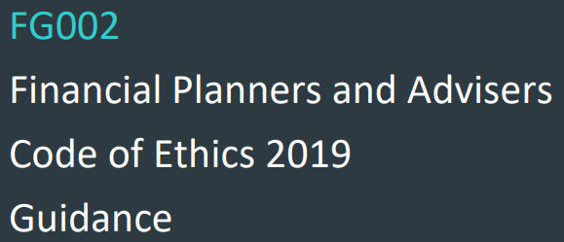
VALUES
Trustworthiness
Competence
Honesty
Fairness
Diligence

STANDARDS

ETHICAL BEHAVIOUR
#1 You must act in accordance with all applicable laws, including this Code, and not try to avoid or circumvent their intent.
#2 You must act with Integrity and in the best interests of each of your clients
#3 You must not advise, refer or act in any other manner where you have a conflict of interest or duty

CLIENT CARE
#4 You may act for a client only with the client’s free, prior and informed consent. If required in the case of an existing client, the consent should be obtained as soon as practicable after this code commences.
#5 All advice and financial product recommendations that you give to a client must be in the best interests of the client and appropriate to the client’s individual circumstances.
You must be satisfied that the client understands your advice, and the benefits, costs and risks of the financial products that you recommend, and you must have reasonable grounds to be satisfied.
# 6 You must take into account the broad effects arising from the client acting on your advice and actively consider the client’s broader, long-term interests and likely circumstances.

QUALITY PROCESS
#7 The client must give free, prior and informed consent to all benefits you and your principal will receive in connection with acting for the client, including any fees for services that may be charged. If required in the case of an existing client, the consent should be obtained as soon as practicable after this code commences.
Except where expressly permitted by the Corporations Act 2001, you may not receive any benefits, in connection with acting for a client, that derive from a third party other than your principal.
You must satisfy yourself that any fees and charges that the client must pay to you or your principal, and any benefits that you or you principal receive, in connection with acting for the client are fair and reasonable, and represent value for money for the client.
#8 You must ensure that your records of clients, including former clients, are kept in a form that is complete and accurate.
#9 All advice you give, and all the products you recommend, to a client must be offered in good faith and with competence and be neither misleading nor deceptive.

PROFESSIONAL COMMITMENT
#10 You must develop, maintain and apply a high level of relevant knowledge and skills
#11 You must cooperate with ASIC and monitoring bodies in any investigation of a breach or potential breach of this Code.
#12 Individually and in cooperation with peers, you must uphold and promote the ethical standards of the profession and hold each other accountable for the protection of the public interest.

