InterPrac Financial Planning Pty Ltd

Compliance Manual Appendices

This document is confidential to Authorised Representatives of InterPrac Financial Planning Pty Ltd (InterPrac Financial Planning). The access, use, copying or reproduction of this document, or any part, by any other person is forbidden and requires the prior written consent of InterPrac Financial Planning.

Version Number | Prepared By | Date
3.5 | Michael Butler & Compliance Team | October 2018

Appendices
The following are examples of registers and or documents referred to throughout the InterPrac Financial Planning Compliance Manual which are presented here for your use.
You can use the registers as they are or you are free to create your own. The important thing is not the format or structure of the document but rather the contents (or information they record) and their correct (appropriate and timely) use.
The Adviser Resource Centre can contain a more updated list of tools. Please check.
Contact the InterPrac Financial Planning Compliance Team with any questions you may have or if you require assistance on (03) 9209 9777.

Section 1 - Compliance Manual

Appendix 1.1A - Definitions

Definitions of common terms used in this manual.

Statement of Advice (SoA) | The document that outlines your recommendations to a retail client that places them in a position to be able to act on your advice as an Authorised  Representative.
Retail client | A client who is not a Professional Investor or Wholesale Client. The definition is important for understanding who is to receive a Statement of  Advice.
Wholesale Client | Typically, a wholesale client (an individual, trust or partnership) has either:  - Net assets exceeding $2.5 million, including net assets of any companies or trusts the client controls, (excluding family home and borrowed amounts) OR  - Earned more than $250,000 gross income per year for the past 2  years (including the companies or trusts that the client controls).  You MUST have a signed declaration confirming the investor’s status as a Wholesale Client, provided by a qualified accountant confirming the client meets the definition of a wholesale client. If you have treated a client as a wholesale client because the met the net assets or gross income tests, you can treat all related companies of the client as wholesale as well, by relying upon the same accountants’ certificate relied upon to treat the individual as a wholesale client.
Professional Investor | A client will be considered to be a Professional Investor if the person has, or  is in control of, gross assets of at least $10 million (including any assets held by an associate or under a trust that the person manages).  You MUST have a signed declaration confirming the investor’s status as a  Professional Investor, provided by a qualified accountant confirming the  client meets the definition of a Professional Investor.
Product provider /  Product issuer | The company that issues the product such as a life company issuing  policies, or a fund manager.
Financial product | The facility through which a person:  - Makes a financial investment (e.g. securities, superannuation, managed funds)  - Manages a financial risk (e.g. risk insurance)  - Makes a non-cash payment (e.g. cheque facilities, EFTPOS)
Financial product advice | A recommendation, statement of opinion or a report on any of the financial products which;  - Is intended to influence a person in making a decision in relation to  a particular financial product or class of financial products; or  - Could reasonably be regarded as being intended to have such influence.  It is important to note financial product advice can be oral, if the consumer perceives it to be such. You should document / file note all conversations. It is important to remember when talking to customers or the public, to be  aware of your stature in the market as a financial planner.
Financial Services  Guide (FGS) | The FSG is the document you are required to give a client BEFORE providing  a financial service.

Section 2 - Compliance & the Regulators

Appendix 2A – Possible Regulatory Enquiries & Investigations

Informal enquiries
Most regulatory activity is informal and consists of responses to complaints, submissions and covert enquiries where it is important to either quickly assess and dismiss allegations or deal with them more thoroughly. Allegations may come from disgruntled employees, clients, competitors or concerned insiders. At this stage most regulators can voluntarily obtain information for analysis. They can share this information with other regulatory agencies and formulate investigation strategies where the information appears to be beginning to look like evidence of serious contraventions of the law.

Surveillance and reviews
Regulators such as ASIC have established surveillance programs for the industries they regulate. Regular or spot inspections are undertaken to supplement regulatory self-reporting requirements or to target areas of particular concern to the regulator. For example, ASIC surveillance or filed inspections cover licence conditions; promotional documents, referrals, procedures and compliance manuals; professional indemnity insurance; financial records and trust accounts; training and monitoring of representatives; and financial capability of the dealer. Regulators usually have formal powers granted to them to require information and assistance during such surveillance operations.

Full investigations to enforcement
For some regulators, the mere suspicion of a contravention of the law they administer is enough to ground a formal investigation. Once this threshold has been reached there is a significant escalation in the arsenal of powers available to regulators. Compulsive powers backed by criminal sanctions for non- compliance which can now be used by regulatory staff include:
  - Statutory notices to compulsorily provide information, reports or books and records and to explain them to investigators (this extends to software and data records).
  - Execution of search warrants and powers of entry (extending to software download).
  - Statutory notices to compulsorily attend for oral examination.
These types of investigatory information-gathering powers expose you and your business to a potentially high level of scrutiny, possible enforcement action and civil litigation from claimants piggy- backing on regulatory actions and adverse publicity. Before we briefly describe these impacts (i.e. just in case you’re not convinced) you should understand some of the complexity that surrounds managing this.

Information gathering powers and due process
Regulators are not entitled to go on a frolic and demand or do anything they want. Given the intrusive nature of their powers they must observe principles of due process when undertaking surveillances or investigations where they are making use of their statutory powers. The investigatory powers and rights of each regulator are governed by different laws, sets of expectations, practices and circumstances.
It is also important that you understand the risk of non-compliance with the reasonable directions of regulators or failure to comply with their information gathering orders can lead to criminal prosecution both of our company and also individual staff, proper authorities and our clients.

Section 2 - Compliance & the Regulators

Appendix 2B – How to Avoid Ombudsman Action

Wealth Professional, 28th November 2012 (FOS Circular, Issue 10 - Winter 2012)
Financial advisers were the fourth-most disputed financial services provider with the Financial Ombudsman Service (FOS) last financial year. Thankfully, FOS has provided the following top 10 tips for financial advisers to keep their backs covered.

Take detailed file notes.
FOS relies on evidence provided by the parties to a dispute. Documents created at the same time as the activity or advice in question are usually given more weight than later recollections of what was said or done. This means contemporaneous file notes of conversations and actions are solid gold when a dispute comes to FOS. Whenever possible, confirm verbal instructions from a client in writing (e.g. send them an email after a telephone conversation confirming what was said).

Use a client's own words
FOS does not consider client objectives and instructions written in industry terms that few clients would understand to be a reliable record. Write down a client’s objectives in the words the client has used in answering your questions about their objectives and how to quantify those objectives. This demonstrates that you have heard and understood the client’s goals in seeking advice – e.g. ‘to retire at age 65 with an income of $50,000 per year’.

Turn clients away when appropriate
If your services are not suited to a particular client (e.g. they are seeking advice about direct shares and you don't provide that service), you must tell them so and send them away. Don't try to shape the client to your offering. If a client is seeking a return which does not match their risk profile and you can’t convince them to change their expectations, either send them away or see Tip 4.

Explain the risks to clients who choose to act against your advice
You must be very clear in explaining the risks and documenting that the course of action is against your advice. Explain the risks in language the client understands make a contemporaneous file note and have the client sign it.

Explain what types of service you are providing
Clients don't know the difference between information, general advice, personal advice and execution- only services. If you don't give the appropriate explanations and warnings or you are unclear, then you could be found liable for advice or activities that you had not intended to provide.

Use template forms and documents carefully
Make sure template forms and documents about strategies, products and risks are appropriate to the client you are advising. It is very difficult to convince us that you have selected the right strategies and financial products for a client if the documents contain errors, are missing information or contain copious amounts of irrelevant material. You will also have some trouble convincing us that the client understood your documents if they contain pro-forma jargon or complex concepts. Tailor documents to your client’s financial literacy. Statements of Advice (SoAs), for example, must be clear, concise and effective.

Use risk profiling tools carefully
Make sure that the strategy and asset allocation you recommend to a client is consistent with risk profile generated by the risk profiling tool you use. If there are inconsistencies, you must clearly explain them. Remember, risk profiling tools are only tools. They all have inherent flaws that must be recognised and addressed by the adviser.

Don't give cookie cutter advice
This is really a reiteration of tips 6 and 7. You should not put all or most of your clients into the same strategy and products, especially not gearing strategies. For example, FOS saw a SoA for a client with taxable income of $42,000 that stated: 'Your reasonable level of surplus income and high tax rate should make gearing an appropriate option for you.

Understand and explain the products
Understand any products you are recommending. Don’t advise on products you don't understand. Don't just hand over a product disclosure statement (PDS) – you must explain the PDS to your client and record your discussion in the SoA. Don't cut and paste PDS disclosures into your SoAs. Show you understand the products by using the same words you use to verbally explain the products to your clients.

Be clear about the advice relationship with clients you know
If you are giving advice to a friend, relative, colleague or employee, it is critical to formalise and document the process as you would for any other client. In addition; declare any conflicts of interest as you would for any other client.

Section 3 – InterPrac Financial Planning AFSL
Appendix 3.7A – InterPrac Adviser Training Register Sample
68
Compliance Manual v3.1

Date | Event | Provider | CPD Hours | Areas Covered | Duration | Results | Docs attached
18/9/13 | Responsible Mgr. Seminar | Compact – Compliance & Training | 4 | Responsible Manager obligations and  liabilities, and licence | 4 hours | Successful Completion | Cert. of attendance

Section 4 - FoFA – Important Changes

Appendix 4.2.2A – InterPrac Fee Disclosure Statement (FDS) Sample (More samples on Adviser Resource Centre)

Client Name Client Address 1
Client Address 2

Dear Client Name
This document is to outline to you all fees received by my practice in relation to your ongoing fee arrangement with us. This statement covers those amounts received in the twelve months up to
{INSERT DATE}.

Income Received | Sub Amount | Total
Initial Advice Fee | $
Plan Fee | $
Implementation Fee | $
One-off Advice Fee | $
Ongoing Advice Fee | $
Contribution Fee | $
Member Advice Fee | $
Trailing Commission – Investment | $
Trailing Commission – Superannuation | $
Trailing Commission – Personal Risk | $
Other | $
Total |  | $

Services Provided
As part of our ongoing fee arrangement, the following is a list of services included.

Service | Provided | Not Provided
Annual/Bi-annual written plan review | ✓ | ✗
Annual/Quarterly/Monthly/Regular Newsletter | ✓ | ✗
Seminar Invitations | ✓ | ✗
Investment balance updates | ✓ | ✗
Review of contributions | ✓ | ✗
Review of personal insurance: cover and premiums | ✓ | ✗
Updates on topical issues | ✓ | ✗
Notification of legislative changes that affect strategy | ✓ | ✗
Meetings with investment and other finance professionals | ✓ | ✗
Personal phone contact | ✓ | ✗
Collection and collation of financial statements and notices | ✓ | ✗
Administration assistance with financial products and their  providers | ✓ | ✗
Birthday card | ✓ | ✗
Christmas card | ✓ | ✗

Kind Regards,

Adviser Name,
Authorised Representative No. Adviser Number
of InterPrac Financial Planning Pty Ltd (AFSL 246638)

Section 4 - FoFA – Important Changes

Appendix 4.4A – Soft Dollar Register

Type of benefit did you receive?  When was the benefit provided and who provided this benefit to you  exceeding $100 in value? | Will the benefit influence a product or service recommendation?  Or is it possible that a client could think it might? | If so, what is the value of the benefit?  Record any benefit between $100 to $300 | Date of entry

Section 4 - FoFA – Important Changes

Appendix 4.4B – Alternate Remuneration Register

Type of payment, when was it paid and who was it paid by? | Will the payment influence the product or service recommendation?  Or is it possible that a client could think it  might? | If so, what is the value of the payment? | What is the amount and is this material? | Does the form of remuneration fall outside of the materiality test? | Date of entry

Section 5 - Margin Lending Gearing Rules

Appendix 5.1.3A – Margin Lending Checklist

Client Name: __________________________________________________
Address __________________________________________________
Client’s Marginal Tax Rate: _____ %
Circle Response
- Has this client had a previous experience with gearing? Yes / No
- Have the risks involved in gearing been fully explained? Yes / No
- Has the client demonstrated their understanding of these risks? (record in file notes) Yes / No
- Has this client previously invested in shares or managed funds? Yes / No
- Is the client prepared to accept the volatility in the price of the investment?
(record in file notes) Yes / No
- Was the client’s investment risk tolerance mutually assessed as Growth/Hi Growth
by both client and adviser? Yes / No
- Is the client’s investment time frame 5 years or more? Yes / No
- Does the client have sufficient excess disposable income to cope with an increase
in repayments if interest rates increase by 3%? (investment income is not to be factored into
meeting loan repayments.) Yes / No
- Does the client have adequate financial resources, including existing investment
capital, that the client is willing to drawdown to meet a margin call if the value in the
investment falls in value? Yes / No
- Has the client demonstrated that the effect of fixed and variable interest rates is
understood? (recorded in file notes) Yes / No
- Does the client have income protection insurance in place? Yes / No
- What is the amount ($ value or percentage of income) of cover this income
protection insurance policy provides for? ___________________
- In consideration of the client’s overall debt situation, have any other necessary
lump sum insurances been explicitly considered? (recorded in file notes) Yes / No
What is the amount ($) of cover ? Life: $ ___________________ Trauma: $ ___________________ TPD: $ ___________________
Is this cover being recommended or already in place and has the adviser assessed suitability
in light of the client’s relevant circumstances. ___________________
- Does the client understand that at the proposed level of gearing, the market would have
to fall by _____% to trigger a margin call situation? (recorded in file notes?) Yes / No
- Does the client want to preserve the level of gearing (loan to value ratio) by:
- Re-investing investment income? Yes / No
B. Making loan repayments from own cash flow? Yes / No
16) Does the client want to increase the level of gearing (loan to value ratio) by:
A. Not re-investing investment income? Yes / No
B. Capitalising interest on loan repayments? Yes / No
Does the client understand /or has been advised on how the arrangement will operate and how this may increase portfolio risk and repayment costs. Yes / No

I have conducted this assessment based upon the responses provided to me by the client and believe that a Margin Loan / Gearing strategy is suitable / unsuitable (Circle the correct outcome for this client.)
_________________________________________ ________________
Adviser Signature Date

Section 6 - Client Communication

Appendix 6.6A – ‘Opt Out’ / No Contact Register

Signature of Compliance Manager
Auth Rep Telephone
Authorised Rep Name & Code
Date
Reason for No Contact?
Client Address if Applicable
Client Contact Number
Client Surname & Name
As an AFS Licensee, we are required to keep a “NO CONTACT REGISTER” and also our Authorised Representatives also need to keep a “NO CONTACT REGISTER”. This register is for the keeping of person’s names and details that do not wish to have any further contact with either the Authorised Representative or the Dealer. Please keep your listing up to date and send InterPrac Financial Planning a copy upon our request on a quarterly basis unless you have an urgent request from a client.

Section 7 - The Financial Planning Process

Appendix 7.2.1A – The Fact Find - Getting to Know Your Client Example

Before you finish the Fact Find ask this final question to the client... Is there anything else I need to know about you and your situation that we have not already discussed?
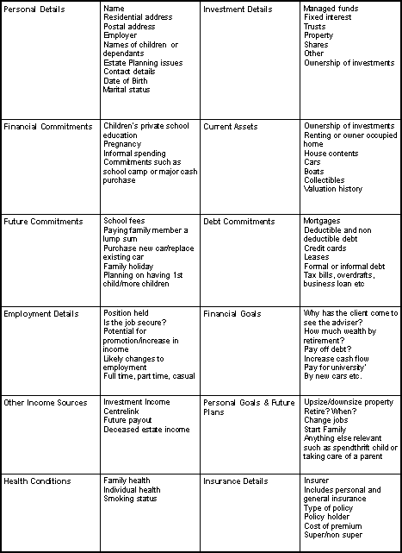

Section 7 - The Financial Planning Process

Appendix 7.2.2A – Risk Profile Example

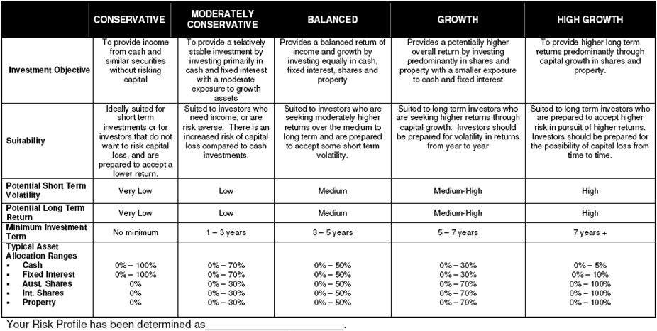

Section 7 - The Financial Planning Process

Appendix 7.3.2A – Statement of Advice - Review Checklist

Statement of Advice – Review Checklist

Instructions
This checklist aims to assist you with the InterPrac Statement of Advice (SoA) preparation process and help you to ensure that the document is compliant with the Corporations Act. This checklist must be used for each SoA prepared from 1 January 2014, and should take no more than ten minutes. If you are unsure of any part of your SoA or would like a second opinion, send your draft SoA (with your completed Fact Finder and this completed checklist) to the National Compliance Manager InterPrac, BEFORE it is sent to your client.
We will review the SoA and respond back to you as soon as possible. Please remember that it is your obligation to retain all SoA documents (and Fact Finds) provided to clients as specified under section 912A of the Corporations Law.

Client name:
Adviser name:
Date of SoA: Date of SoA Review:

Please respond to each question below in the space provided | Yes or  No
Have you identified the objectives, financial situation and needs of the client through the fact find process and their instructions to you?
Have you identified that the subject matter of the advice that has been sought by the client is relevant to their needs, objectives and financial situation?
If the information relating to the client’s relevant personal circumstances was incomplete or inaccurate have you made reasonable enquiries to complete it? If it is incomplete or inaccurate you should only provide a “limited scope” Statement of Advice and you must advise the client of this, and include an
incomplete information warning.
Do you have sufficient expertise to provide advice on the subject matter, (as supported by your
knowledge, training and current CPD training hours and if not have you declined to provide the advice?
In light of the client’s current situation and personal circumstances, is it reasonable to recommend the strategy, financial solution or product/s?
Have you made reasonable investigations and conducted research into the recommended strategies and or financial product solutions that will achieve the objectives and needs of the client AND have you given
reasonable consideration to the relevant financial issues impacting on the advice provided?
Is the advice based on the client’s relevant personal circumstances and are the recommended products (or advice solutions) consistent with the client’s risk profile?
Have you taken reasonable steps to ensure that the client is in a better position if they followed your advice?
Is the advice appropriate and in the best interest of the client?
Have you adequately considered the age, income, wealth, education, training, work background, prior
investment experience and similar subjective characteristics of the client?
Has the SoA been provided reasonably soon after the advice has been given?
Is the advice short and simple and easy to understand?
Is the SoA presented in a clear, concise and effective manner?

Have extraneous material (such as projections and cash flows) been excluded from the body of the SoA and provided separately as an appendix item?
Are the client’s financial circumstances (income and assets) described competently?
Does the SoA include a generic description of the class of financial products recommended?
Is the advice summarised in an executive summary if the SoA is over ten pages in length?
Does the SoA state the reasons why the advice / recommendation is appropriate, including the alternatives considered as well as the advantages and disadvantages for the client if the advice is acted on?
Is enough detail provided to allow the client to make a decision to acquire the financial products
recommended in the SoA?
Has tax been considered and has this been stated in the SoA?
Has the risk connected to the product recommended been disclosed for that product and generally for that class of products?
If a product switch or a replacement product has been recommended, have the switching rules been provided? AND Have additional statements been provided regarding the clients’ existing products, the cost of changes considered, any potential benefits that may be lost or any other significant consequences
included?
If a product switch or a replacement product has been recommended and involves superannuation (such as a superannuation rollover) - does the SoA, make it clear that the new fund is expected to provide a
better after tax net return than the old fund?
If a SMSF has been recommended has the dollar benefits now and the expected future dollar benefits including the related costs of the SMSF been considered?
If a borrowing strategy in relation to SMSF is being recommended, has the time order been followed (covering preparation of the SoA, then the set-up of the SMSF followed by the set-up of the bare trust
and then signing the land contract)?
Has the issue of conflicted remuneration been considered and disclosed appropriately?
Is the “Statement of Advice” title on the front page or near front page?
Are the InterPrac Financial Planning name, address and AFSL number on the front page or near front page of the SoA?
Is there a clear statement that the adviser is an InterPrac Authorised Representative including the AR number?
Is there a statement setting out the advice including information on which the advice is based and information about remuneration, commissions and other benefits payable to InterPrac or the adviser as well as all benefits in dollar terms (and or percentage terms) and tables used for comparisons, where required? Also, is information about any referral arrangements and any relationships that may influence
the advice included?
Is there a statement included providing an incomplete information warning?
Have you ensured the words “independent” or “unbiased” have not been used?
Have you ensured that all possible false or misleading statements, particularly about future performance
been excluded from the SoA?

If you have answered “YES” to every question - your SoA should meet current InterPrac, ASIC and Corporation Law requirements. You can now present the SoA to the client and ensure they sign the Authority to Proceed before beginning the implementation of your advice.
If you have answered “NO” to any questions, you MUST consider the possible deficiencies identified and their impact on the advice being provided to the client as well as the impact on your adherence to your compliance requirements.
Please retain this document with your SoA as evidence that you have undertaken the SoA review for the benefit of your clients and your business (as well as the InterPrac Financial Planning AFSL).

Section 7 - The Financial Planning Process

Appendix 7.4A – Wholesale Client / Sophisticated Investor Declaration Form
Wholesale Client /
Sophisticated Investor Declaration

I hereby confirm that I, , am and can be classified as a ‘Wholesale Client’ / 'Sophisticated Investor', being an investor who is deemed to have sufficient investing experience and knowledge to weigh the risks and merits of an investment opportunity.

My net worth can be demonstrated to be classified as a Sophisticated Investor because:
- My net worth (including net assets of any companies or trusts I control) exceeds $10 million of assets (excluding the family home and any borrowed amount).

My net worth and income restrictions can be demonstrated to be classified as a Wholesale Client because:
- My net worth (including net assets of any companies or trusts I control) exceeds $2.5 million of assets (excluding the family home and any borrowed amount) and / or
- I have earned more than $250,000 per year for the past two years (including income from companies or trusts I control).

Therefore, I qualify for the exemption.

Name of investor:

Signature of investor:

Date: / /

Name of accountant:

Signature of accountant:

Date: / /

Section 7 - The Financial Planning Process

Appendix 7.5A – Ongoing Client Service Program Example

Package | Ongoing Service Provided | Ongoing Annual Fee
A | - Regular monitoring of and (where appropriate) rebalancing of your investment and or insurance portfolio’s.  - Open availability for information and balances from staff.  - Two formal reviews per year held in our office.  - Monthly email with your portfolio valuations.  - Periodic client newsletters.  - Special update letters or offers.  - Invitations to seminars where deemed appropriate.  - Priority access to your financial planner usually within 4 working hours of contact and when the office is open.  - Availability to external technical specialists, if required. | 0.6%pa with a minimum fee of $4,200 per annum. This is based on your portfolio valuation at the time and excludes borrowed funds.  Based on a minimum of 20 hours work.
B | - Two formal reviews per year held in our office.  - Quarterly email with your portfolio valuations.  - Periodic client newsletters.  - Special update letters or offers.  - Invitations to seminars where deemed appropriate.  - Priority access to your financial planner usually within 12 working hours of contact and when the office is open. | 0.6%pa with a minimum fee of $3,600 per annum. This is based on your portfolio valuation at the time and excludes borrowed funds.  Based on a minimum of 16 hours work.
C | - Annual formal review per year held in our office.  - Quarterly email with your portfolio valuations.  - Periodic client newsletters.  - Special update letters or offers.  - Access to your financial planner usually within 24 working hours of contact and when the office is open. | 0.6%pa with a minimum fee of $2,100 per annum. This is based on your portfolio valuation at the time and excludes borrowed funds.  Based on a minimum of  10 hours work.
D | - Annual formal review  - Bi-annual email with your portfolio valuations  - Access to your financial planner usually within 48 hours of contact and when the office is open. | 0.6%pa with a minimum fee of $1,050 per annum. This is based on your portfolio valuation at the time and excludes borrowed funds.  Based on a minimum of 5  hours work.
No Ongoing Service | Any services provided, including time on the phone or response required via email or other form of communication will be charged  out at $300 per hour pro-rated (minimum $50 per contact) | No Ongoing service provided
- Please note – all fees are exclusive of GST. GST will be added to your invoice or payment plan.

In reference to access to your financial planner, please be advised that we will endeavour to return your call or query whenever possible but we do take occasional holidays, we are not open on weekends or public holidays. In addition, we attend training conferences and training days which is why our office is closed and may limit our capacity to respond to your query. If this is the case, we will inform you before- hand and will attend to your needs on our return.

Section 8 - Records of Advice (RoA)

Appendix 8.6A – Record of Advice Checklist

Client name: Was the advice given by: Telephone / Meeting / Writing (Circle the correct response)

Date of this advice:

Date of previous SoA or Record of Advice (the ‘previous advice’):

Has there been any significant change in the client’s personal circumstances since the previous advice
(you must make enquires of the client):
NO (Circle if No) or YES (Circle if Yes and produce a new Statement of Advice)
What checks did you undertake to determine that there have been no significant changes in the client’s
circumstances?

Has there been any significant change to the basis of the advice since the previous advice? (Such as the class of product which is the subject of this RoA different to the previous advice) (Circle appropriate response)
NO or YES (If Yes produce a new Statement of Advice)
Your advice (If written advice was provided to the client, attach it to this Record of Advice)

State the reasons why your advice is appropriate for this client.

Did you recommend that the client switch from one financial product to another? (Circle appropriate response)
NO or YES
If YES – did you disclose (and state what was disclosed):
That the clients existing product had been considered Any exit fees and current MER for the existing product Entry fees and MER for new product Any benefits that the client will lose because of your recommendation Any other consequences for the client because of the recommendation (are to be noted below)

Does this recommendation result in any fees or commissions to the licensee or adviser? (Circle appropriate response)
NO or YES
If YES, you must disclose this remuneration to the client. What did you disclose to the client?

Signed (Adviser):
Name (Adviser): Date: / /

Section 9 - Recommended Product List

Appendix 9.6A – Adviser’s Product Research Sample Pro-forma

Adviser Name
Date
Product
Recommendation List Morningstar Rating
Personal Research Undertaken on Product
Comments

Section 10 - Conflicts of Interest

Appendix 10.2A – Conflicts of Interest Register Sample

Date | What and where does a possible conflict exist | How will the conflict be managed? | How has the conflict been disclosed? | Further action or follow up required

Section 11 - Client Complaints
Appendix 11A – Client Complaints Register
83
Compliance Manual v3.1

Date | Client Name, Address and contact number | Details and response to the complaint | Date Referred to  InterPrac | Referred to external body | Signed by InterPrac Compliance  Manager

Section 12 – Incident Reporting – Notifying ASIC of Breaches and Events
Appendix 12A – Incident Register - Sample
84
Compliance Manual v3.1

Date of Incident | Date Incident Detected | How Incident Detected | Details of Incident (Describe incident and where further  information can be found) | Action required and person responsible (Who will do what to  action the incident) | Date Incident Resolved | Reason Incident is not a Breach of Financial Service laws or AFSL Conditions (e.g. internal policy breach)

Section 12 – Incident Reporting – Notifying ASIC of Breaches and Events
Appendix 12B – Breach Register - Sample
85
Compliance Manual v3.1

Name & position of reportee | Date of Actual or Likely Breach | Date Breach Detected | How Breach Detected | Details of Breach | Assess Frequency of similar previous breaches | Assess Impact on ability to provide  Fin. Services | Assess extent indicates inadequate compliance | Assess actual / possible financial loss | Date ASIC Notified (Significant Breach) | Action Required and Person Responsible

Section 13 – Anti-Money Laundering & Counter-Terrorism Finance Act

Appendix 13.2A – Collecting Customer Identification Process

ID not previously received

Does the Fund Manager require ID documents?

NO YES

Collect ID as specified in the tables following (see below 13.2C)

Comply with their requirements and keep on file.

Confirm 2 of: Name Address DOB

YES NO

You need to be satisfied with further verification documents. These may include their rates notice, utilities bill, marriage certificate or deed poll.

Proceed with the application and keep the copies of all the
YES NO

identification documents on file.
Proceed with application and keep copies of identification documents on file.
Report Suspicious AML or CTF Matter Complete and send a report via email to InterPrac Financial Planning and include the nature of your suspicion.

Even when formal AML/CTF proformas may not be explicitly required, it is ideal to complete the most relevant proforma anyway. The proformas incorporate a declaration that you have explicitly followed a process in conformity with AML/CTF requirements.

Section 13 – Anti-Money Laundering & Counter-Terrorism Finance Act

Appendix 13.2B – Risk Assessment Worksheet

These tables provide guidelines for determining how much identification is required and examples of the types of behaviour and circumstances that should be considered suspicious. While the tables prescribe when you MUST report to InterPrac Financial Planning, you are encouraged to report all matters where you have any suspicions or concerns.

Column 1 Residency Status | Column 2 Known to you | Column 3  Level of Identification | Column 4  Suspicious Requests or Behaviour
3  International client | 2  No | 3  Unsatisfactory | 3  Request of payments to third parties  Placing investments in names other than their own  Wash through transactions Unexplained wealth Cash transactions Unusual requests
2  Non - resident | 1  Client is referred from a trusted source | 2  Inconsistent ID unsatisfied  OR 1  Inconsistent ID satisfied
1  Resident | 0  Yes | 0  Satisfactory ID provided

Determining Risk Score
Risk Score | Score from Columns 1 to 3 | Score includes Column 4
3 or less | The client needs to provide standard identification documents | Not Applicable
4 or 5 | Please collect 2 additional identification documents from the lists following. If you are satisfied with the further documentation it is OK to proceed. If the client is unable to provide satisfactory documentation refer the matter to InterPrac Financial Planning. | You need to collect further information or source evidence that explains the request, behaviour or suspicion. If satisfied with the further information or evidence you can proceed, otherwise report the matter to InterPrac Financial Planning
6 or more | Report to InterPrac Financial Planning for determination | Report to InterPrac Financial Planning for determination

Section 13 – Anti-Money Laundering & Counter-Terrorism Finance Act

Appendix 13.2C – AML/CTF Identification & Verification Documentation Checklist

Individual A  Please provide the required documentation from either A or B | An original or Certified Copy of one of the following:  - An Australian Drivers Licence that contains a photograph of the licence/permit holder.  - An Australian Passport;  - An identification card issued by a state or territory that contains the date of birth  and a photograph of the card holder.  - A current driver’s licence issued by a foreign country that contains a photograph  of the person. A passport or other document of identity for the purpose of  international travel that contains a photograph and signature of the passport holder and is issued by a foreign government, the UN or a UN agency and if written in a different language other than English, is accompanied by an English translation prepared by an accredited translator.  - A national identification card that contains a photograph and signature of the  card holder and issued by a foreign government, the UN or a UN agency and if  written in a different language other than English, is accompanied by an English translation prepared by an accredited translator.  If they are a sole trader, please provide:  - A business name search.
Individual B | An original or Certified Copy of one of the following:  - A birth certificate or extract issued by a state or territory.  - A birth certificate issued by a foreign government, the UN or a UN agency and if  written in a different language other than English, is accompanied by an English  translation prepared by an accredited translator.  - An Australian citizenship certificate.  - A citizenship certificate issued by a foreign government and if written in a  different language other than English, is accompanied by an English translation  prepared by an accredited translator.  - A pension card issued by Centrelink that entitles the card holder to financial benefits.  PLUS  An original or Certified Copy of one of the following:  - A notice relating to the provision of financial benefits issued by the state or territory or the Commonwealth within the preceding 12 months and contains the name and residential address of the individual.  - A notice issued by the Australian Taxation Office within the preceding 12 months  relating to a debt payable to or by an individual and contains the name and  address of the individual.  - A rates notice issued to an individual by a local government or utilities provider within the preceding 3 months and contains the name and address of the individual.  - In relation to an individual under the age of 18, a notice issued to the individual  by a school principal within the preceding 3 months and that records the time  that individual attended the school and the name and residential address of the individual.
Company | Please provide:  - A full company search of the ASIC database showing:  - The full name of the company.  - The ACN (or if applicable, the ARBN for a foreign company registered with ASIC).  - The registered office address of the company.  - The principle place of business of the company.  - The names of each director of the company (only for proprietary company).

 | - The shareholders of the company (for all proprietary companies that are regulatory oversight of a Commonwealth, state or territory regulator).
- If the company is a regulated company, a search of the licence or other
Commonwealth, state or territory statutory regulator.
- Confirmation that the company is listed (or a majority owned subsidiary of a listed company) in the financial market.
- If the company is a foreign company not registered with ASIC, then a search of
the relevant foreign register of companies (or if the above search is not readily
available, a certificate of registration).
Trust | Please provide:  - For a registered management investment scheme:  - An ASIC search confirming the registration of the managed investment  scheme.  - For government superannuation fund:  - An extract from relevant legislation confirming the establishment of the  government superannuation fund.  - For an unregistered managed investment scheme that only has wholesale / sophisticated clients and does not make small scale offerings under 1012E of the corporations Act 2001, a declaration checkbox is provided to this effect in the  application form.  - For all other trusts (including wrap trusts, master trusts, IDPS):  - The original trust deed or a Certified Copy or Certified Extract of the  trust deed confirming the full name of the trust.  - The name of each beneficiary or class of beneficiary.  - If the trustee is an individual, please also provide documentation required for individuals (above).  - If the Trustee is a company, please also provide documentation required for companies (above).  PLUS for foreign trusts, provide one of:  - A Certified Copy or Certified Extract of documents creating the trust (including confirmation of the country where the trust is established).  - The name of each beneficiary or class of beneficiary.  PLUS in relation to the trustee:  - If the trustee is an individual, please also provide documentation required for individuals (above).  - If the Trustee is a company, please also provide documentation required for companies (above).
Partnership | Please provide:  - An original partnership agreement, Certified Copy or Certified Extract of the partnership agreement.  - A Certified Copy or Certified Extract of minutes of partnership meeting.  - The full name and address of each partner in the partnership.  PLUS  Please provide the documentation required for individuals (noted above) for one of the partners.

Section 13 – Anti-Money Laundering & Counter-Terrorism Finance Act

Appendix 13.2D – AML/CTF Certification Wording Sample

An example of wording that may be used by an Authorised Person to certify a copy of identification for AML / CTF purposes is:
“I certify that I have seen the original documentation and this copy is a complete and accurate copy of
that original and matches the name, address, and date of birth provided.” Name: …………………………………………………………………… Address: …………………………………………………………………
…………………………………………………………………
………………………………………………………………… Occupation: ………………………………………………………………… Signature: …………………………………………….…………………… Date: ……………………………………………………………………

Authorised Person
One of the following persons:
  - A legal practitioner enrolled on the role of the Supreme Court of a state or territory, or the High Court of Australia.
  - A Judge, registrar or deputy registrar of a court.
  - A Magistrate.
  - A chief executive officer of a Commonwealth Court.
  - A Justice of the Peace.
  - A notary public (for the purpose of Statutory Declaration regulations 1993).
  - A police officer.
  - An agent of the Australian Postal Corporation who is in charge of an office supplying postal services to the public.
  - A permanent employee of the Australian Postal Corporation with two or more years of continuous service who is employed in an office supplying postal services to the public.
  - An Australian consular officer or an Australian diplomatic officer (within the meaning of the Consular Fees Act 1955).
  - A finance company officer with two or more years of continuous years of service with one or more finance institutions (for the purpose of Statutory Declaration Regulations 1993).
  - An officer with, or authorised representative of, a holder of an Australian Financial Services
Licence, having two or more year’s continuous service with one or more licensees.
  - A member of the Institute of Chartered Accountants in Australia, CPA Australia or the National Institute of Accountants with two or more years continuous membership.

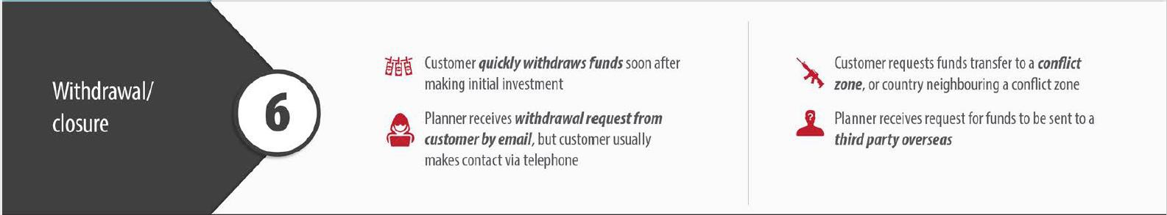
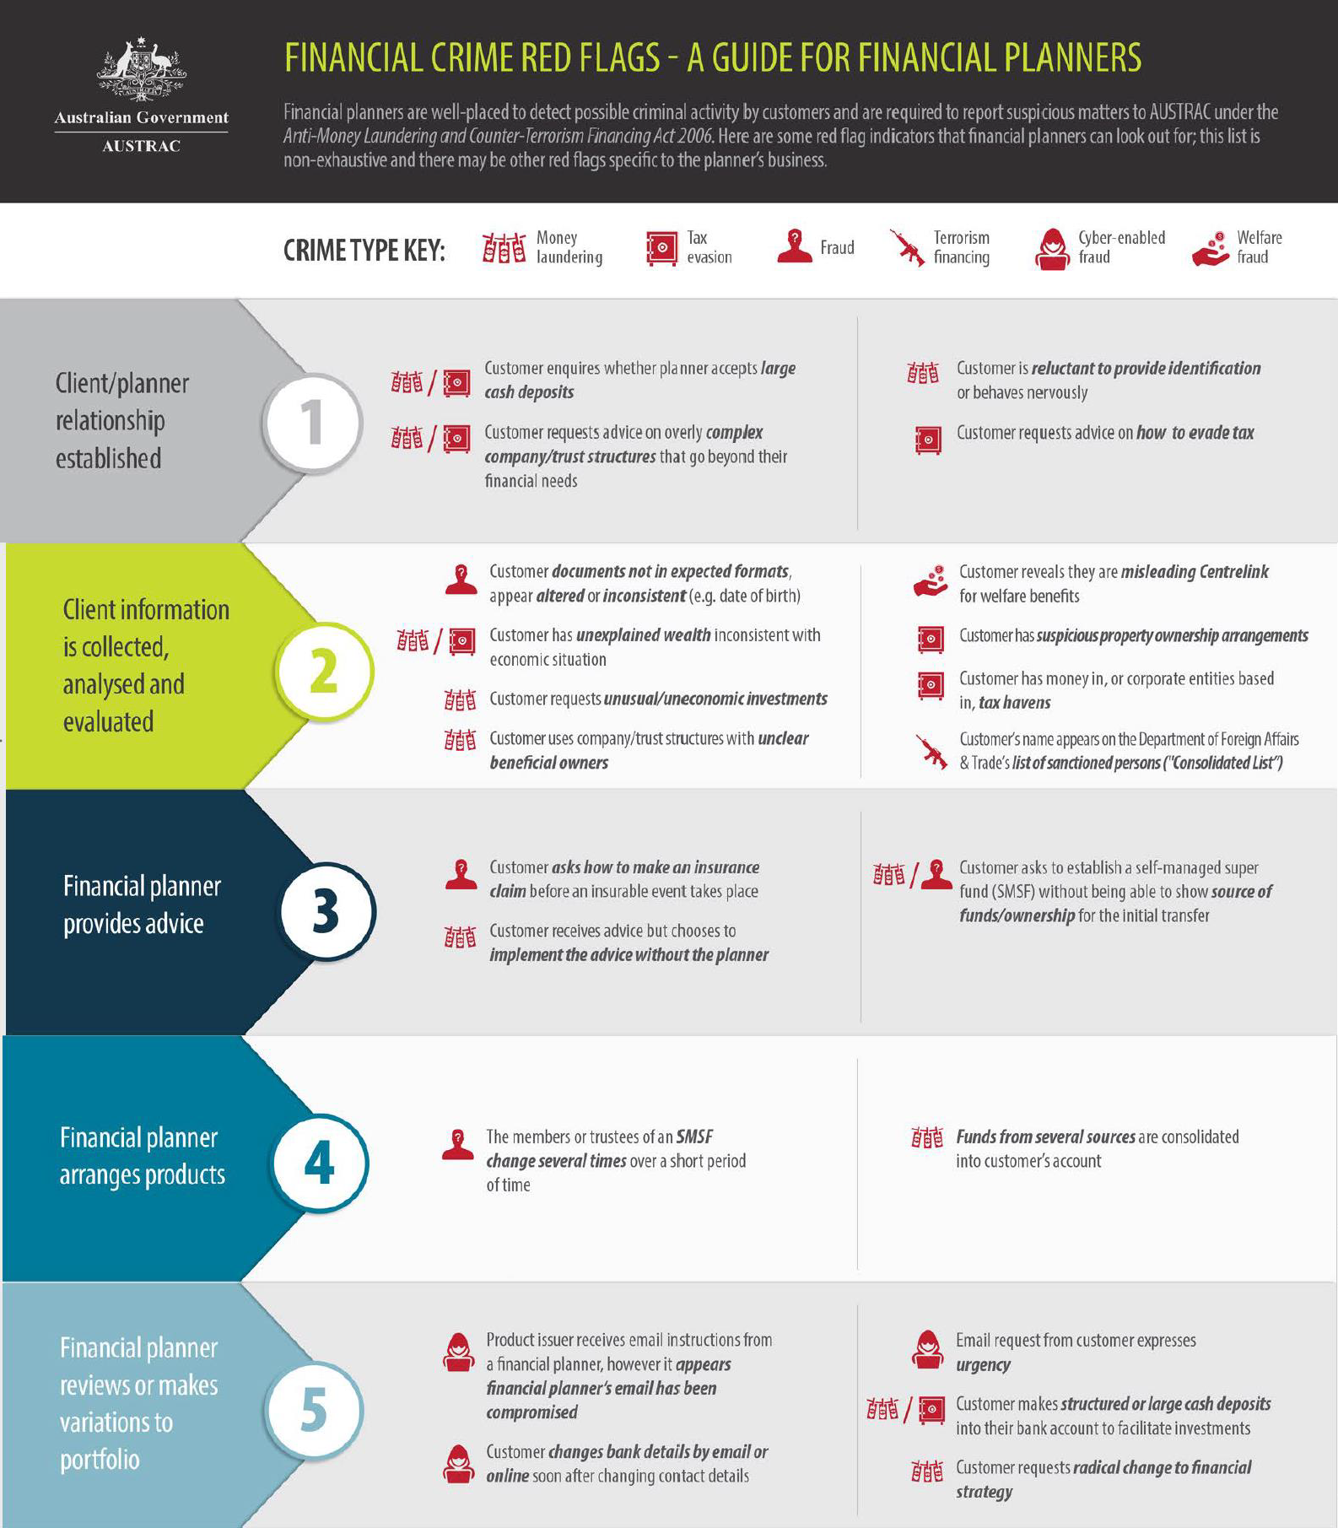
Section 13 – Anti-Money Laundering & Counter-Terrorism Finance Act

Appendix 13.2E – Suspicious Matter Reporting

