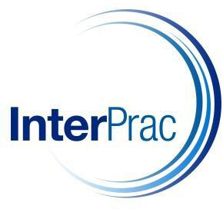

InterPrac Financial Planning Pty Ltd

Compliance Manual
Internal Usage of Compliance Staff

This document is confidential to Authorised Representatives of InterPrac & Libertas Financial Planning Pty Ltd. The access, use, copying or reproduction of this document, or any part, by any other person is forbidden and requires the prior written consent of Compliance at InterPrac Financial Planning.

Version Number | Prepared By | Date
1.5 | Shane Miller | 12 August 2020

CONTENTS
COMPLIANCE CALENDAR 4
SEQUOIA GROUP RISK MANGEMENT FRAMEWORK 7
SEQUOIA GROUP PRIVACY POLICY 9
COMPLIANCE SCHEMES 10
INTERPRAC LICENSEE OBLIGATIONS 12
RESPONSIBLE MANAGERS (RMs)** 15
CULTURE AND GOVERNANCE 17
FINANCIAL PRODUCT ADVISERS: CONDUCT AND DISCLOSURE 18
PROVIDING OVERSIGHT OF ADVISERS 21
ONBOARDING ADVISERS 24
FINANCIAL ADVICE REGISTER 26
REVOCATION OF ADVISERS 28
LIMITED ADVICE LICENSEES 29
CREDIT LICENSEES 31
TAX FINANCIAL ADVISERS 32
AUDITING ADVICE PRACTICES 34
AUDITING ADVICE PRACTICES _ COVID (Remote FourthLine Process) 36
EDUCATION & TRAINING OF ADVISERS 37
BREACH REPORTING and REGISTERS 39
ASIC ENFORCEMENT_ TOOLS & PRINCIPLES 42
FASEA CODE OF ETHICS 44
VALUES & STANDARDS 44
CODE MONITORING 45
CLIENT DEALINGS 46
BEST INTERESTS DUTY 46
FINANCIAL SERVICES GUIDE 47
CONFLICT OF INTEREST 49
FEE FOR SERVICE / OPT IN 51
AML / CTF 53
DISPUTE RESOLUTION 56
PRIVACY & DATA BREACHES 63
AUSTRALIAN PRIVACY PRINCIPLES 63
NOTIFIABLE DATA BREACHES SCHEME 64
CLIENT ADVICE 67
GENERAL ADVICE AND FACTUAL INFORMATION 67
HOLISTIC AND SCALED ADVICE 69
FINANCIAL PRODUCT ADVICE, DEALING AND ARRANGING 71
PREVET PROCESS 72
POSTVET REVIEWS 73
STATEMENT OF ADVICE 75
RECORD OF ADVICE 77
INCORPORATION BY REFERENCE 79
TIME CRITICAL ADVICE 80
SMSF ADVICE 81
INSURANCE ADVICE 83
GEARING ADVICE 84
DISCLOSURE _ SECURITIES 86
SOPHISTICATED AND WHOLESALE CLIENTS 88
PROVIDING TAX ADVICE 89
TRANSACTION ONLY SERVICES 90

COMPLIANCE CALENDAR
Updated July 2020; Source: Holley Nethercote Compliance Diary

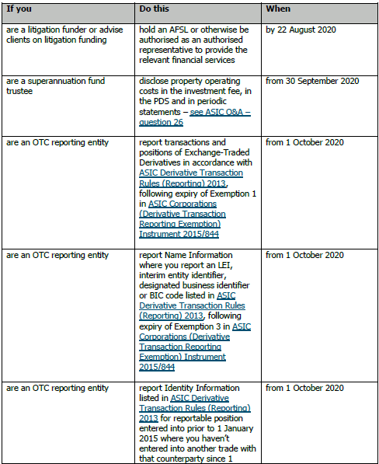

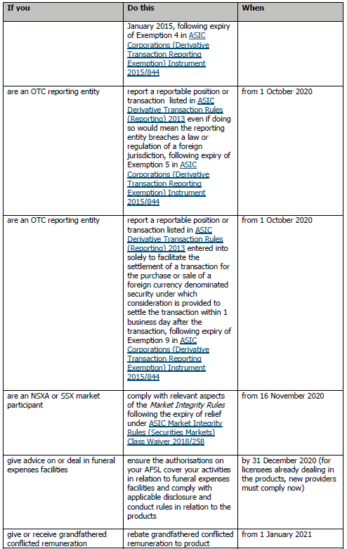
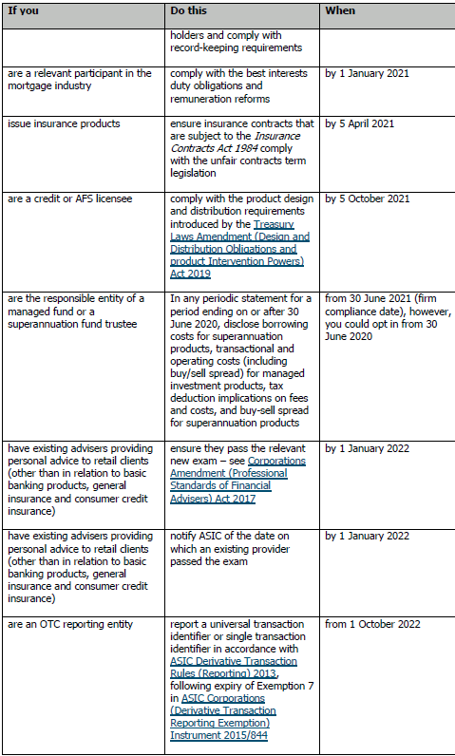
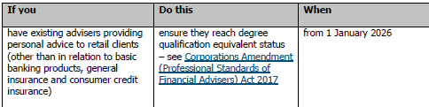

SEQUOIA GROUP RISK MANGEMENT FRAMEWORK
Pending.
The most recent updated proxy is the Risk Management Framework for Morrison Securities. Relevant excerpts:
“The Risk Management Framework incorporates active management and monitoring of a range of risks. These include but are not limited to credit, market and clearing risks. The Framework applies to all business activities …. Policies and procedures are in place to manage the risks arising in all operations. Formalising practices and principles into policies assists in the consistent management of risks. It also results in the sharing of experience and expertise gained from managing risks in various business activities.
(The) Board is ultimately responsible for the overall management of risks and for defining the responsibility and authority of those who act on a day-to-day basis. (The) Board may also delegate some of its responsibilities to manage risk to individuals in the firm.

In determining the relevant risks to be addressed, the Board interacts with internal and external stakeholders to ensure that all relevant risks are addressed. …..key risk management policies are reviewed annually by the Board.

This Framework also ….:
- complies with Section 912A(1)(h) of the Corporations Act 2001 (Cth) and its AFS Licence Conditions;
- recognises and manages risk and provides guidance;
- outlines and assigns responsibilities for risk management and oversight through the firm;
- promotes ethical and responsible decision-making;
- implements an effective reporting structure,
- identifies key business risks to protect the firm against market, credit, liquidity, operational and legal risks.

(We) has identified our key risks in six distinct areas:
- Financial Risk – risk in relation to the financial requirements of Morrisons
- Business Risk – risk to business as a whole
- Compliance Risk – legislative risk
- Board and Management Oversight
- Operational Risk
- Trading Risk

…. core risk management principles include:
- Risk accountability: Staff are accountable for identifying risks and ensuring they are appropriately managed. Before making decisions, clear analysis of the risks is sought to ensure those taken are consistent with the Risk Management Framework.
- Understanding of risks: Highly experienced professionals … use both quantitative and qualitative inputs to examine the risk consequences of decisions and determine whether these are acceptable.
- Risk independents: (we) place significant importance on having strong, independent Risk and Compliance teams.
(The) Risk Management Framework assigns clear risk roles and responsibilities represented by 'three lines of defence’:

- Primary responsibility for risk management lies at the business level. This is the first line of defence. Part of the role of all staff … is to ensure they manage risks appropriately.
- The risk and compliance function form the second line of defence and independently assesses material risks.
- The third line, an independent audit function can be used to review and challenge the risk management controls, processes and systems.
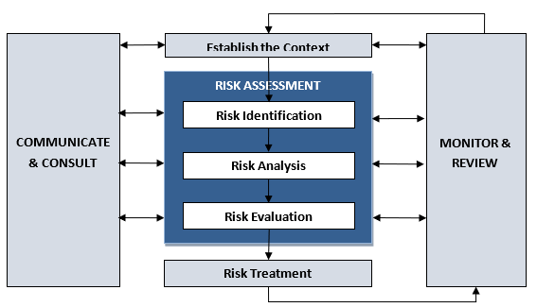

Risk treatment involves selecting one or more options for modifying risks and implementing those options. These options can include the following:

- avoiding the risk by deciding not to start or continue with the activity that gives rise to the risk;
- taking or increasing the risk in order to pursue an opportunity;
- removing the risk source;
- changing the likelihood;
- changing the consequences;
- sharing the risk with another party or parties (including contracts and risk financing); and
- retaining the risk by informed decision.

(We have) incorporated maintenance functions within the Risk Management Framework, including:

- ongoing review of the process by the Head of Risk and Compliance
- monitoring of the system by the Head of Risk and Compliance, and
- periodic consultation with external professional advisers.

The Head of Risk and Compliance shall oversee compliance with this Framework. This will be done through regular and random testing and auditing. There shall be appropriate reporting on risk to the Credit Risk Committee, Risk and Compliance Committee and (the) Board from the Head of Risk and Compliance.

External consultants may be used periodically, to advise areas of weaknesses. Any weaknesses found are addressed and related policies and procedures updated. The entire Risk Management Framework is reviewed annually.

This Framework document will be reviewed at least annually, with the Head of Risk and Compliance facilitating the review process and recommending any changes to (the) Board.

This Framework may only be amended with the approval of the (the) Board.

SEQUOIA GROUP PRIVACY POLICY

Pending

COMPLIANCE SCHEMES
Regulatory Guidance
ASIC’s Consultation Paper “Approval and oversight of compliance schemes for Financial Advisers” (CP 300) provides an insight into the general concerns of the Regulator driving the creation and performance of any Compliance Scheme that applies to the provision of financial advice.
From 1 January 2020, authorised representatives advising retail clients will need to comply with a Code of Ethics and be monitored by the Licensee.
(refer: FASEA CODE of ETHICS)
ASIC will not be monitoring or enforcing the Code of Ethics (ASIC 19-319 MR) and is specifically prevented by The Corporations Act from banning an adviser for breaches of the Code. Accordingly, ASIC will take a facilitative role only.
ASIC will:
  - provide training and/or guidance to advisers on the types of conduct that is consistent/inconsistent with the code;
  - aid advisers to raise concerns with their Licensee about how the licensee’s systems and controls may be hindering their ability to comply with the code, and acting on those concerns where appropriate;
  - consider whether advisers are complying with the code as part of their regular, ongoing monitoring of adviser conduct; and
  - consider the decisions of the anticipated disciplinary body and making any necessary changes to their systems and processes.

The essential motivation is ASIC’s determination to improve professional standards:
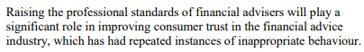
This goal is to be achieved by:
- New education and training requirements (s921B, C)
- Mandatory compliance with a Code of Ethics monitored by a Compliance Scheme (s921E, H)
- Restriction on the usage of the term ‘financial adviser’& ‘financial planner’ (s923C)
The Code of Ethics are aimed to encourage higher standards than are mandated by legal obligations.
Encouraging:
- Behavioural change
- Transparency
- Consistency and Fairness
Following the Treasurer’s announcement on 11th Oct 2019 that the anticipated Code Monitoring body would be replaced by a single disciplinary body, ASIC announced a 3-year exemption effective from 1 Jan 2020, for Licensees to register their advisers under a Compliance Scheme (ASIC 19-280 MR).

Interprac’s Operational Response
Registering with a Monitoring Body
- InterPrac, as policy, will ensure a timely registration with the anticipated disciplinary body.

Code of Ethics
- Prior to 1 Jan 2020, InterPrac did not operate under a uniform Professional Code of Conduct but
  - InterPrac remains a member of the AIOFP

  - our ARs, in addition to being members of the CPA, NTAA, CA or ICA for their Accounting activities

  - our ARs can elect to be a member of the FPA or AFA or the SAFA professional bodies who all offer varying Professional Codes of Conduct

- From 1 Jan 2020, InterPrac will actively promote & enforce compliance with the FASEA Code of Ethics with those relevant providers, and eligible provisional relevant providers, who offer personal and general advice to retail clients.

(refer: EDUCATION and TRAINING of ADVISERS)

INTERPRAC LICENSEE OBLIGATIONS
Regulatory Guidance
ASIC’s Regulatory Guide “Meeting the general Obligations” (RG 104) indicates the broad scope of Licensee obligations (cf. RG 36: 96-100)
Including:
- A general obligation to provide financial services efficiently, honestly and fairly (s912A(1)(a))

- Specific obligations minimally relating to:
  - conduct and disclosure
  - the provision of your financial services
  - the competence, knowledge and skills of Responsible Managers, as well as their good fame and character
  - the training and competence of ARs
  - ensuring ARs comply with the financial services laws
  - compliance, managing conflicts of interest and risk management
  - the adequacy of financial, technological and human resources
  - dispute resolution and compensation arrangements (for retail clients)
Holistically, these impact upon:
  - provisions of adequate financing (RG 166)
  - adequate human resources (S912)
  - robust internal systems (s912): risk management; resolution of conflicts of interest; dispute resolution
  - staff (s912) who are trained & competent to comply with financial services laws and regulations
  - tracking of & accountability for outsourced functions
ASIC’s Regulatory Guide “Risk Management Systems of Responsible Entities” (RG 259) further fleshes out the expectations for Licensees to develop and maintain a risk management system (s912A(1)(h)) that:
- ensures clearly defined roles and responsibilities;
- assesses and identifies material risks of the entities’ business(s)
- ensures adequate controls in place to manage the risks identified
- ensures there is adequate oversight & reporting by both the party responsible for ownership of the risk and the compliance function
- states the responsible entity’s risk appetite and the risk tolerance for each material risk identified
- fosters a strong risk management culture
- takes into account relevant industry, local and international guidance
- includes a liquidity risk management process
- is subject to regular review
- independently monitors and assesses the performance of 3rd party service providers

The Hayne Royal Commission into Misconduct in the Banking, Superannuation & Financial Services Industry has emphasised the ‘look through’ responsibilities that the Licensee (Director, RSE) holds in relation to the ultimate retail consumer:
In regards to superannuation … “ASIC’s role in superannuation primarily concerns the relationship between RSE licensees and individual consumers.”
In regards to regulating conduct … “ASIC should be given the power to enforce all provisions in the SIS Act that are, or will become, civil penalty provisions or otherwise give rise to a cause of action against an RSE licensee or director for conduct that may harm a consumer.”
In regards to lending … “The NCCP Act obliges credit licensees to assess whether the proposed credit contract or increase in credit limit will be unsuitable for the consumer.”
In regards to administrative processes … “Those sections oblige a financial services licensee and a credit licensee respectively to do all things necessary to ensure that the services covered by their licensees are provided efficiently, honestly and fairly.”
In regards to Fee for Service … “The fees were deducted automatically from clients’ accounts. Many licensees did not keep records that would allow them to determine whether the promised services were delivered”
In regards compliance systems …” Further, as I noted in the Interim Report, one of the requirements of the ANZ and CBA EUs was to have senior management attest that the relevant licensee’s compliance systems and processes were (at the time of the undertaking) reasonably adequate to track the licensee’s contractual obligations to its ongoing service clients.”

Interprac’s Operational Response
- Documenting the Risk Management System
InterPrac has prepared a methodology document entitled “InterPrac: Risk Management Process” for the guidance of the Compliance Teams and Responsible Managers.
Scope:
  - Responsible Officer’s obligations
  - ASIC’s requirements
  - Risk Identification
  - Assessment of Likelihood of Risk
  - Determining Consequences of Risk
  - Management of Risk
  - Communication
  - Ongoing Monitoring and Review

- Monitoring & Review of Risk Management Systems

- Compliance Meeting
The Compliance Senior Managers and Responsible Managers meet periodically to:
  - assess risks and determine risk management strategies
  - review compliance team financial and human resourcing

- Team Meeting
Monthly, the wider compliance team meet (NCM, compliance managers)
The agenda routinely includes:
  - communication of assessed risks and risk management strategies

- Look-through to the Retail Client

- InterPrac undertakes reviews of retail clients’ SoAs with the aim of determining appropriateness of the advice in the Best Interests of the end-user retail client.

- InterPrac undertakes site audits randomly choosing retail client SoAs with the aim of determining appropriateness of the advice & the integrity of the advice process in the Best Interest of the end-use retail client.

- InterPrac proactively undertook a survey of retail clients fee for service arrangements in July 2018. The aim was to determine the transparency and integrity of F4S process in the Best Interest of the end-use retail client.

- InterPrac reactively undertook a survey of retail clients Fee for Service arrangements in December 2019. The aim was to remediate clients who were involved in legislatively invalid Ongoing arrangements.

RESPONSIBLE MANAGERS (RMs)**
** previously called Responsible Officers (RG 105)
Regulatory Guidance
ASIC’s eLicensing ‘sample Application’ proforma https://download.asic.gov.au/media/5538220/sample-afs-licence-application-published-1-april-2020.pdf indicates/implies:
• RMs are of good fame and character
• RMs have the relevant knowledge, skills and experience to perform their particular roles within the business
• the RM’s organisation will continue to have, measures in place to maintain the competence required to provide the financial services applied for
• the RM’s organisation will continue to have, appropriate measures in place to provide the financial services applied for in this application efficiently, honestly and fairly
• the RM’s organisation will maintain, compliance measures that are appropriate and will ensure that it complies with the obligations under the financial services laws
• the RM’s organisation will maintain, adequate monitoring, supervision and training procedures to ensure that representatives will comply with the requirements of the financial services laws, are properly trained and are competent to undertake their role when they join the financial services business and on an ongoing basis
• the RM’s organisation has sufficient resources available to meet its obligations under the financial services laws and will continue to have sufficient resources on an ongoing basis, including:
• adequate human resources to enable it to satisfy its obligations under the financial services laws;
• adequate technological resources to enable it to satisfy its obligations under the financial services laws
• adequate financial resources to enable it to satisfy its obligations under the financial services laws.
• the RM’s organisation will continue to have, appropriate internal and external dispute resolution procedures to resolve complaints made in connection with the provision of the financial services applied for in this application.
• the RM’s organisation has established and will maintain adequate risk management systems that take into account the nature, scale and complexity of this financial services business and include a focus on its obligations under the financial services laws
• the RM’s organisation will maintain, compensation arrangements that comply with the requirements of the financial services laws
• the RM’s organisation will continue to have, sufficient financial resources available to meet the financial requirements set out in ASIC's Regulatory Guide 166 Licensing: Financial requirements (RG 166)

ASIC’s Regulatory Guide “Licensing: Organisational Competence” (RG 105) further details:
- In a large business, there should be at least two RMs.
- Knowledge and skills of these RMs must be maintained and recorded
- If it is assessed that their competence cannot be maintained or is not sufficiently comprehensive, then this is Breach and must be reported to ASIC (s912D)
- Eligibility to be a RM implies that the candidate is responsible for significant, day-to-day decisions
- RMs monitor the provision of the organisation’s financial services and must have needed visibility upon Operations
ASIC’s Regulatory Guide “Credit licensing: Competence and training” (RG 206) further details:
- RMS must obtain relevant CPD of at least 20 hours per year
- RMs must be ‘fit and proper’ persons with active operational responsibility
Interprac’s Operational Response
- InterPrac has two Responsible Managers:
Garry Crole, Mark Phillips
- Credit Licence Qualification:
Cert IV of Financial Services (Mortgage Broking) FNS40804 held by Garry Crole
- Financial Services Qualification:
Garry Crole _ Dip Financial Services (Distribution) FNB 50499
- Licensed/Experienced as a Financial Adviser:
Both Garry Crole 000271677 and Mark Phillips 000237149 (subject to FASEA education and CPD requirements)
- Licensed/Experienced in SMSF Administration:
Mark Phillips
- Responsible Decisioning:
Garry Crole _ InterPrac’s Managing Director
- Ongoing Education:
- Both RMs have CPD targets in excess of 20 hours (refer: INTERPRAC CPD POLICY)
- CPD is recorded on the OnTrack system and monitoring reports produced periodically for both Garry Crole and Mark Phillips.

CULTURE AND GOVERNANCE

Regulatory Guidance
The Hayne Royal Commission (Recommendation 5.6) requires that all financial services entities take proper steps to:
- Assess the entity’s culture and its governance
- Identify any problems with that culture and Governance
- Deal with any identified problems
- Determine whether the interventions have been effective

Interprac’s Operational Response
- In Nov 2019, InterPrac appointed a senior Head of Risk & Compliance; reporting directly to the CEO of Sequoia.
The role will oversee the ongoing monitoring and management of organisational risk and seek to instil a culture of risk management as a benefit to customers and our broader stakeholders.

FINANCIAL PRODUCT ADVISERS: CONDUCT AND DISCLOSURE
Regulatory Guidance
ASIC’s Regulatory Guide “Licensing: Financial product advisers – Conduct and disclosure” (RG 175) details the key processes (conduct) surrounding the provision of advice (personal, general) and advice services (needful disclosures).
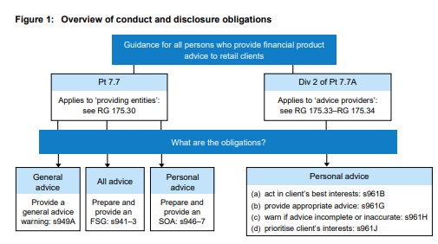
Specific Disclosure obligations:
- FSG
- Statement of Advice (SOA)
- General Advice Disclaimer “ASIC Corporations (General Advice Warning) Instrument 2015/540)”
- The client is warned that the advice is “general”
  - It may not be appropriate for the client
- Product Disclosure Statement
- Duty to disclose any Conflict of Interest
- Duty to disclose remuneration, commission and other benefits
- Duty to disclose when an authorised representative is advising a retail client via an intermediary (secondary services)
The document defines “Financial Product Advice” as any advice that is intended, or can be interpreted to intend, to influence a retail client to make a decision about a financial product. It must take into account the clients’ needs, financial situation & objectives and is therefore personal advice. (RG 175.46).
AFS Licensees must monitor and enforce provision of appropriate Financial Advice in accordance with the Corporations Law Division 2 Part 7.7A.
The document defines “Retail Client” to mean any advice recipient who is not:
- a sophisticated, wholesale or professional investor;
- a Trustee of: a superannuation fund; an approved deposit fund; a PST; or a large public sector super scheme;
- an RSE provider;
- a person who the Licensee is satisfied has sufficient experience to assess the risks inherent in products and services
General Advice is not ‘personal advice’ and may be practically equated with factual advice. It does not take into account the client’s relevant circumstances.
Interprac’s Operational Response
Monitoring Advisers
(refer: PROVIDING OVERSIGHT OF ADVISERS)
Financial Services Guide
Words such as ‘independently owned’, ‘non-aligned’ and ‘non institutionally owned’, and other similar words or expressions, are also restricted under s923A.
(refer: FINANCIAL SERVICES GUIDE)
Statement of Advice
(refer: STATEMENT OF ADVICE)
Retail Client
(refer: SOPHISTICATED / WHOLESALE INVESTOR)
General Advice
(refer: GENERAL ADVICE)
Marketing and Advertisements
Words ‘independent’, ‘impartial’ and ‘unbiased’ are restricted terms if a financial services provider does not satisfy the conditions in s923A.
InterPrac has a marketing department that reviews websites, social media communications and advertising. This typically occurs:
- when onboarding a new authorised representative
- upon request of an authorised representative
- by random, proactive survey

(refer: ONBOARDING ADVISERS)
(refer: FINANCIAL SERVICES GUIDE)
Provision of PDS
(refer: STATEMENT OF ADVICE)
Conflict of Interest
(refer: CONFLICTS OF INTEREST)
Remuneration, Commission and Other Benefits (soft dollar)
(refer: FEES FOR SERVICE. OPT IN)
(refer: FINANCIAL SERVICES GUIDE)
(refer: BREACH REPORTING & REGISTERS)
(refer: STATEMENT OF ADVICE)
Secondary Services (Sequoia’s wider services)
InterPrac is a wholly owned subsidiary of Sequoia Financial Group.
Certain of Sequoia’s divisions (eg. Sequoia Wealth Management; SMSF Engine) may offer personal financial advice to Retail Investors who may be referred to them by InterPrac advisers.
In all cases, when personal advice is provided by these other divisions, it is disclosed by those other divisions as advice that is not attributable to the InterPrac authorised representative. (RG 175.132)

PROVIDING OVERSIGHT OF ADVISERS
Regulatory Guidance
ASIC’s Report “Financial advice: Review of how large institutions oversee their advisers” (REP 515) indirectly provides insight into the scope & principles of Oversight that is to guide InterPrac as a Licensee.
ASIC seeks to promote investor and consumer trust. This can be achieved if financial advisers:
- act professionally, avoid conflicts of interest and treat customers fairly
- deliver strategic financial advice that is aligned with customer needs and preferences
- ensure that customers are fully compensated when loss or detriment results from poor conduct.
ASIC identifies organisational culture and collective industry norms as key influencers upon Advisers.
Organisational Culture is identified with shared values and assumptions but indicated by:
- the way that an institution deals with advisers whose conduct has been identified as non-compliant
- how an institution remediates customers who have been adversely affected by receiving non-compliant advice
- how effectively an institution’s monitoring and supervision processes identify adviser non-compliance.
ASIC also emphasises the
- adequacy of the licensees’ background and reference-checking processes when appointing new advisers
- effectiveness of the licensees’ adviser audit processes
- use of data analytics

Interprac’s Operational Response
Acting Professionally and fairly
- A culture of professionalism is promoted:
  - The Licensee maintains a comprehensive repository of “Business Principles” which available to advisers online via it’s Adviser Resource Centre.

These documents comprehensively detail InterPrac’s requirements for ARs in the provision of advice and services.

  - Annual Adviser Conference
Plenary sessions are conducted to educate advisers regarding their professional responsibilities. These vary from year to year.

  - Adviser small group discussion and feedback sessions are promoted locally with the aim of information sharing and dissemination of best practice behaviours. Agendas vary periodically and by attendees.

  - Site Visits by the Compliance Team informally reinforce Best Practice behaviours.

  - Site Audits by the Compliance Team formally reinforce Best Practice behaviours.
(refer: AUDITING ADVICE PRACTICES)

A 3rd party (FourthLine) software is used selectively for PreVet SoA and Remote site audits. It combines Artificial Intelligence and human oversight to deliver scores and commentary that form the basis for further review by InterPrac compliance managers. (refer: Adviser Newsletter _ “Compliance Update Autumn 2020” pgs 3-5)

  - Compliance newsletters are prepared from time to time to educate advisers regarding their professional responsibilities.

  - The compliance team provides a Help Desk to answer technical compliance queries and to educate advisers regarding their professional responsibilities

- ‘Fairness’ is promoted as a principle:
  - Training materials on ethical principles are provided thru Kaplan OnTrack system. This training is monitored and checked for Implementation as per FASEA principles and use that to notify the Licensee
  - Annual Adviser Conference
  - Adviser small group discussions
  - Site visitation by the compliance team
  - Site audit by the compliance team
  - Compliance newsletters
  - Compliance Help Desk activity

Avoiding Conflicts of Interest
(refer: CONFLICTS OF INTEREST)
Strategic Financial Advice _ aligned to customer needs and preferences
(refer: BEST INTEREST DUTY)
(refer: BUSINESS PRINCIPLES _BEST INTEREST DUTY)
Monitoring advisers
InterPrac monitors Advisers using the following methodologies:
  - PreVet Process
  - Site Visitation
  - Site Audit
  - Data Analytics (see below)
  - Proactive submission of Breach & Incident Registers by advisers
  - Proactive Suspicious Matter Reporting by advisers
  - Proactive Data Breach reporting by advisers
  - Appropriate information sharing within the InterPrac teams (eg. BDMs, SMSF Engine)

(refer: AUDITING ADVICE PRACTICES)

Supervising advisers - Warnings & Disciplinary actions
If issues are detected that act counter to the Bests Interests Duty obligation for Clients:
- Remediation is routinely identified by the Compliance team on minor matters
- The National Compliance manager will issue both Remediation and Warnings to advisers who repeatedly offend on minor matters
- The National Compliance manager will revoke the authorisation of a representative who fails to respond positively to the remediation identified for repeated minor offences
- The National Compliance manager will revoke the authorisation of a representative who commits a serious breach.
(refer: REVOCATION OF ADVISERS, DISPUTE RESOLUTION, BREACH REPORTING, PRIVACY AND DATA BREACHES, AUDITING ADVICE PRACTICES)

Remediation and Compensation
(refer: DISPUTE RESOLUTION)
Reference Checking
(refer: ONBOARDING ADVISERS)
Data analytics
The following data collection and analytical opportunities are used:
  - Adviser ‘Risk Assessment’
Prior to a site audit/visitation, data relevant to the Adviser and advice practice is routinely pre-assessed by the compliance team and a report prepared for review by the National Compliance Manager. From this report, specific tailored emphases of the upcoming visit are determined.
This report will typically encompass:
- Findings of previous audits
- Issues uncovered in the initial PreVet process
- A high-level analysis of the results of a Qssnr that had been supplied to the practice in advance of the site visit
  - Approved CRM platform(s) that are used by Advisers are interrogated for specific purpose reports from time to time

  - Random written survey(s) of selected groups of advisers are conducted from time to time. Specific purpose reports are produced.

  - Kaplan Ontrack reports are prepared from time to time to monitor compliance with FASEA training requirements

  - InterPrac’s Adviser payments system (PayLogic) is interrogated for specific purpose reports from time to time.
These reports can be used to identify the fees and charges remitted by clients. This data can in turn be used as a basis for the determination of fairness in regards to adviser remuneration versus Advice and service provision.

ONBOARDING ADVISERS
Regulatory Guidance
Checking on the qualifications, past conduct, and good fame & character of prospective Authorised Representative is an obligation of Licensees.
(refer: INTERPRAC LICENSEE OBLIGATIONS)
(refer: PROVIDING OVERSIGHT OF ADVISERS)
Sections 916 A-F Corporations Act 2001 and Corporations Regulations 7.6.04AA and 7.6.08 of the Corporations Regulation 2001, relate to the appointment and cessation of authorised representatives by Australian Financial Services (AFS) licensees.
https://asic.gov.au/for-finance-professionals/afs-licensees/appointing-and-ceasing-an-afs-authorised-representative/#how
Under these provisions:
- Notification of authorisation must be in writing
- an adviser’s scope of authorisation may be all, or part, of the Licensees licenced services
- an adviser may be the authorised by 2 or more AFS licensees but only if each consents, or each of the licensees is a related body corporate of an overarching licensee. (s916C)
- ASIC must be notified of authorisation within 30 days of that authorisation being issued

ASIC INFO 91 “Who can be an authorised representative of an AFS Licensee” identifies
- individuals,
- bodies corporate,
- partnerships, or
- a group of individuals and/or bodies corporate that are the trustees of a trust.
An AR can sub-authorise individuals with the consent of the Licensee.
ASIC INFO 88 “Notifying ASIC of the appointment of Authorised Representatives” adds that notifications are to be made online via ASIC Connect.
- Employers need not advise ASIC of any sub-authorisation if:
  - an employee is sub-authorised
  - and general advice / dealing involves general insurance, basic deposit products & related non-cash facilities
  - and personal advice involves only basic deposit products & related non-cash facilities
--()--
For Tax Practitioners Board Requirements:
(refer: TAX FINANCIAL ADVISERS)

Interprac’s Operational Response
Onboarding Process
InterPrac details the process in a procedure: “Admin Tasks – Processes; Onboarding & Offboarding”
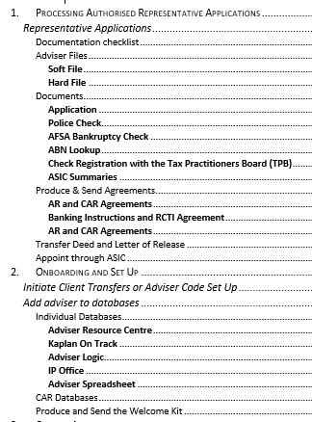
Reference Checking
InterPrac chooses to adopt the ABA standard
CPD/CPE History
InterPrac’s approach to CPD/CPE is in its CPD Policy document
(refer: Business Principles _ Continuing Professional Development (CPD) )
Authoriser
InterPrac retains the sole right of authorisation. ARs are typically authorised individually and sub-authorised under a CAR.
Scope of ARs Authorisation
Detailed in ARs Financial Services Guide.
Inclusive of InterPrac as the Licensee and any other related authorised entities.
(refer: Business Principles _ Authorisations and Adviser Obligations)
Tax Practitioner’s Board
Potential ARs must provide a certificate of registration which is then verified for the individual (or the CAR).

FINANCIAL ADVICE REGISTER
Regulatory Guidance
Maintained by ASIC, Licensees are responsible for entering and updating ARs on this register within 30 business days.
https://asic.gov.au/for-finance-professionals/afs-licensees/financial-advisers-register/information-on-the-financial-advisers-register/
The following details are required:

Date of appointment to the AFS licence
Representative number
Australian Business Number (ABN)
Given name
Other given names
Family name
Date of birth
Country of birth
State/territory of birth, if in Australia
Suburb/city of birth, if in Australia
Principal place of business
Email address
Adviser role type:
financial adviser
provisional financial adviser
time-share adviser

Also:
- The financial products for which the AR may provide advice.
- Qualifications
Name of course
Provider/Institution
Year attained
Type of course (AQF level)
- Date passed the FASEA Exam
- Continuing Professional Development
CPD year start date
Date when a financial adviser failed to meet their CPD requirements

- Professional Memberships
- Compliance Scheme Membership
(this requirement is currently subject to a 3-year exemption from ASIC)

Interprac’s Operational Response
(refer: ONBOARDING ADVISERS)
Providing Gearing Advice
Although FSGs may generically disclose a Margin Lending advice authorisation, an Adviser may only proactively recommend the adoption of a Margin Lending strategy if the Adviser’s FAR Register evidences a Margin Lending qualification.
This same qualification formally permits an Adviser to proactively recommend that a client commence an LRBA or non-super gearing strategy.
Without a formal Margin Lending qualification, the FSG authorisation specifically limits an Adviser to only discuss the implications of, or do projections/calculations for, a pre-existing gearing strategy or a strategy that the client has proactively disclosed they will undertake of their own choice.

REVOCATION OF ADVISERS
Regulatory Guidance
Enforcement of regulatory and licensee standards may result in termination of an Adviser’s authorisation (revocation).
If an Adviser voluntarily wants to cease authorisation with InterPrac then that also constitutes revocation.
Sections 916 A-F Corporations Act 2001 and Corporations Regulations 7.6.04AA and 7.6.08 of the Corporations Regulation 2001, relate to the appointment and cessation of authorised representatives by Australian Financial Services (AFS) licensees.
Under these provisions:
- Notice of Revocation must be provided in writing
- ASIC must be notified of revocation within 30 days of that revocation being issued
ASIC INFO 88 “Notifying ASIC of the appointment of Authorised Representatives” adds that revocations are to be made online via ASIC Connect.

Interprac’s Operational Response
Enforcement & Monitoring
A representative who fails to demonstrate mastery in the PreVet Process may have their authorisation revoked.
(refer: PREVET PROCESS)

Revocation Process
InterPrac details the process in a procedure: “Admin Tasks – Processes; Onboarding & Offboarding”
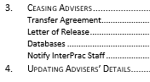

LIMITED ADVICE LICENSEES

Regulatory Guidance
ASIC defines a “Limited Advice Licensee” (https://asic.gov.au/for-finance-professionals/afs-licensees/limited-afs-licensees/) as an individual or an entity that limits the authorisation for personal advice to only one of**:
- SMSF
OR
- ‘Class of product advice’ (not specific products##)
  - superannuation
  - securities
  - simple managed investment schemes as per Corporations Regulations 2001 (regulation 1.0.0.2)
  - general insurance
  - life risk insurance
  - basic deposit products
OR
- arranging to deal (apply for, acquire, issue, dispose) in an interest in a SMSF on behalf of another

** ASIC’s Information Sheet 227 “What can Limited AFS Licensees do?”
## ASIC’s Information Sheet 216 “AFS Licensing requirements for Accountants who provide SMSF Services” defines the SMSF as a financial product requiring a licence for personal advice. It further defines ‘Class of product advice’.
InterPrac references the limited adviser as a Limited Advice Representative (LAR); to distinguish from the more broadly licensed adviser (AR).
ASIC’s Information Sheet 228 “Limited AFS Licensee: Advice Conduct and Disclosure Obligations” provides that the LAR:
- has a FSG
- is subject to the Best Interests Duty; esp. Safe Harbour Steps
- give scaled advice consistent with the client’s relevant circumstances
- must provide “Appropriate” advice
  - fit for purpose
  - leaves the client in a better position
- must make reasonable enquiry to obtain complete and accurate information
- must advise clients of any risks, costs or responsibilities should the client follow the advice
- must ensure the advice provides an overall advantage to the client
- must record advice and information relied upon in the determination of the advice and (as licensed) products recommended eg. SoA, File Notes, PDS
- Must avoid conflicted remuneration
- Must comply with FDS & Opt-In rules if entering into an Ongoing Fee Arrangement
ASIC’s Information Sheet 229 “Limited AFS Licensees: Complying with your Licensing Obligations” lists the following obligations:
- Typically, the LAR must comply with the same obligations as an AR.
- Must operate within the Scope of the limited licence
- Must comply with Training Corporations Amendment (Professional Standards of Financial Advisers) Act 2017 and Ethical standards
- Must appear on the Financial Advisers Register (FAR)
(refer: FINANCIAL ADVICE REGISTER)
- Must have an (Internal) & be part of (External) a dispute resolution scheme
- Must have sufficient resources to compensate clients as required
- Maintain solvency
- Avoid false and misleading representations

Interprac’s Operational Response
- InterPrac limits limited authorisation to qualified accountants giving SMSF Advice only.
The LAR must operate in a practice structure in which there is a fully authorised AR.

- LAR’s all have their own FSG disclosing the scope of their licensed advice

- LARs are required to do a comprehensive fact-finding and product research process
They are provided full access to the Licensees website tools.
- LARS are required to maintain the full suite of Compliance Registers

- LARS are required to comply with AML/CTF obligations

- LARS are subject to the same obligations as ARs (see sections 3,4 of this manual).

- LARs are subject to InterPrac’s PreVet process and site visitation (practice audit).
(refer: PROVIDING OVERSIGHT OF ADVISERS)
- InterPrac provides a limited Advice document template applicable solely to the establishment of a SMSF.

CREDIT LICENSEES
Regulatory Guidance
An Australian Credit Licence is required for an adviser if credit activity involves:
- providing credit under a credit contract or consumer lease
- benefiting from mortgages or guarantees relating to a credit contract
- exercising rights or performing obligations of a credit provider
- suggesting or assisting with a particular credit contract or consumer lease
- acting as an intermediary between a credit provider and a consumer

ASIC’s Regulatory Guide “Applying for and Varying a Credit Licence” (RG 204) provides key requirements:
- Fit and proper person (RG 205)
- Acting efficiently, honestly and fairly
- Managing Conflicts of Interest (RG 205)
- Supervision and Training of Representatives (RG 206)
- Adequacy of Resources (RG 205)
- Dispute Resolution & hardship applications (RG 207)
- IDR
- EDR
- Risk Management (RG 205)
- Compensation Arrangements (RG 210)

In December 2019, ASIC updated its guidance on responsible lending practices (ASIC 19-342 MR; RG 209)
https://download.asic.gov.au/media/5402601/navigation-guide-attachment-to-rg-209-comparison-of-2014-and-2019-versions.pdf

Interprac’s Operational Response
Credit Licensee
<TBA>

Responsible Manager
(refer: RESPONSIBLE MANAGERS (RMs))

TAX FINANCIAL ADVISERS
Tax Financial Advisers (Tfa) are governed by the Tax Practitioners Board.
https://www.tpb.gov.au/tax-financial-advisers
The term ‘Tfa’ excludes registered Tax Agents or legal professionals.
Regulatory Guidance
The TPB defines a tax financial adviser as an individual, or entity, providing advice on the tax consequences of financial advice for a fee or reward.
  - A Tfa must be at least 18 years old
  - Must be a fit and proper person
  - Must maintain professional indemnity insurance
  - Met qualifications and relevant experience requirements
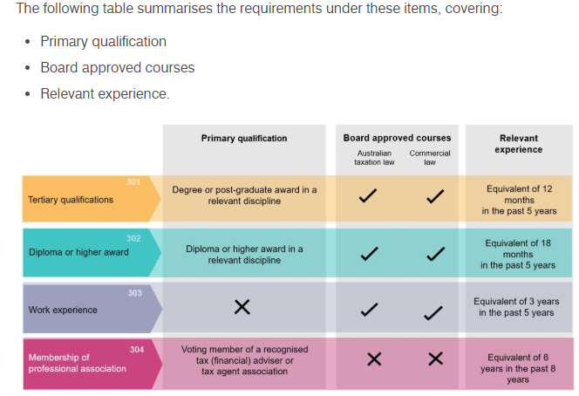

A Tfa must meet continuing professional education (CPE) standards – 60 hours within a triennium.
A Tfa must operate under a Code of Professional Conduct.
https://www.tpb.gov.au/comply-code-professional-conduct-for-tax-financial-advisers
Honesty & Integrity
- Act honestly and with integrity; having adequate arrangement to manage any conflicts of interest. (TPB(I) 30/2016)
- Comply with the taxation laws in the conduct of one’s personal affairs.
- Upon receipt of money, or other property from or on behalf of a client, one must hold that money or other property on trust
Must account to your client for the money or other property.
Independence
- Act lawfully in the best interests of your client. (TPB(I) 27/2016)
- Have in place adequate arrangements for the management of conflicts of interest that may arise in relation to the activities undertaken
Confidentiality
- Unless under a legal duty, must not disclose any information relating to a client’s affairs to a third party without your client’s permission.
Competence
- Must act competently.
- Maintain knowledge and skills relevant to the tax services provided.
- Must take reasonable care to ascertain a client’s state of affairs, to the extent that they are relevant to the advice or service. (TPB(I) 28/2016)
- Ensure that taxation laws are applied correctly to the circumstances of the advice. (TPB(I) 29/2016)
Other Responsibilities
- Must not knowingly obstruct the proper administration of the taxation laws.
- Advise clients of their rights and obligations under the taxation laws as relevant to the advice or services provided.
- Maintain professional indemnity insurance.
- Respond to requests and directions from the Tax Practitioners Board in a timely, responsible and reasonable manner.

Interprac’s Operational Response
Qualifications & Registration
- InterPrac’s Tfa’s are all registered as either Tfa’s (or Tax Agents if appropriately qualified).

Initial Qualifications are assessed at Onboarding.
(refer: ONBOARDING ADVISERS)
Conflicts of Interest (COI)
- InterPrac advisers must maintain a COI register and report to the Licensee upon any entries to that register
Ongoing Professional Development
- InterPrac provides suitable training content thru the Kaplan OnTrack system. Successfully completed CPD activity is recorded on the OnTrack system.

- InterPrac assesses non-Kaplan training for content suitable for Tfas. InterPrac does not provide, nor assess, Tax Agent training or content.

- Tfas must accrue 60 hours of eligible tax-related training in a triennium

Code of Professional Conduct
- InterPrac subscribes to the TPB code of Conduct for registered Tfas and Tax Agents.

AUDITING ADVICE PRACTICES

Regulatory Guidance
(refer: PRINCIPLES_PROVIDING OVERSIGHT OF ADVISERS)
Interprac’s Operational Response
Frequency
InterPrac visits Adviser’s sites on average every 12 – 18 months after the PreVet process has been completed following Onboarding.
(refer: PREVET PROCESS)
(refer: ONBOARDING ADVISERS)
Aims
The aims of the site audit are to:
- review client advice to ensure the Best Interests Duty is being routinely evidenced
- monitor the provision of advice services to ensure implementations are managed efficiently, honestly and fairly
- ensure that Ongoing Fee Arrangements are being conducted in accordance with regulatory guidelines
- check that all necessary compliance documentation is current (eg. FSG, AML/CTF, checklists) and being used with clients appropriately
- to perform face-to-face training
- support the development of an InterPrac culture that encourages accountability, continuing personal development and the Best Interest of the Client

Process
InterPrac has detailed a ‘InterPrac Practice Audit Procedure’ which is available separately to this Manual. It is updated as material changes to the process occur.
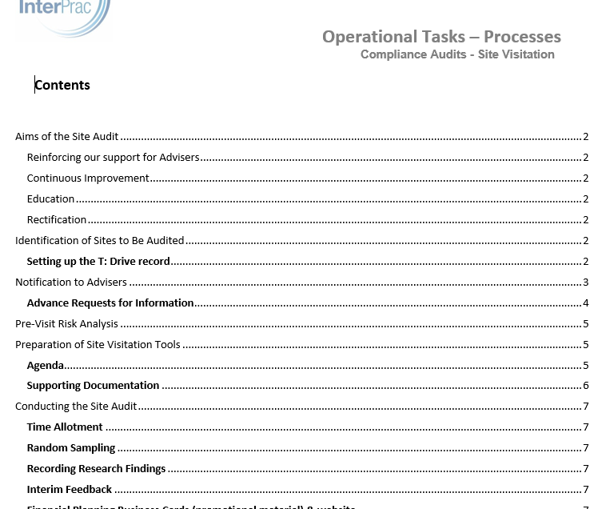
When Breaches or Incidents are detected that have not been proactively reported by an Adviser, the appropriate Licensee registers are updated before:
  - reporting to ASIC upon significant matters
  - reporting to AUSTRAC on suspicious matters
  - remedial activity, accompanied by education and training, is mandated for less significant matters
Record Keeping
Key dates, reviewed exhibits, reviewer reports and follow up activities are recorded in both the CRM and server directories.
Remedial Activities
There is no practical limitation upon suitable remediation activities that might be required of an adviser.
However, in summary, the usual activities include:
  - As appropriate, returning the client to the same position they were in prior to an advice
  - Requiring missed documentation to be prepared and distributed as appropriate
  - Mandate more transparent or comprehensive disclosures to the client
  - Rewrite advice documents and re-distribute
  - Desk Audit reviews of any new advice documentation before client presentation.
  - Desk Audit reviews of any new implementation documents before actioning.

As required, a Licensee’s authorisation can be suspended or revoked.
(refer: REVOCATION OF ADVISERS)

AUDITING ADVICE PRACTICES _ COVID (Remote FourthLine Process)
Regulatory Guidance

Interprac’s Operational Response
(refer: T: Financial Planning/Compliance/Compliance Desk Audits incl. FourthLine process/
Fourth Line Procedure for Remote Site Audit v1.1)
Process:
- Request made to adviser to notify Remote Audit is upcoming – send files for review.
Typically: SoA/Fact Find/Risk Profiling
- Forward files to Administrative assistant to upload to Fourth Line system
- Administrative assistant will set up a sub-folder _ by Adviser_ in Practice Reviews (T:) to house the completed report.
A spreadsheet is maintained to show the status of FourthLine processing:
(refer: T: Financial Planning/Compliance/_AA_Compliance Key Documents/FourthLine/Fourth Line - Audited Advisers.xls )
- Send adviser an email to set up the Remote Audit web meeting
- Conduct the meeting with the adviser at the meeting time
- Prepare a Summary email for the adviser; updating AdviserLogic

Typical T: Drive file
Typical AdviserLogic entry:

EDUCATION & TRAINING OF ADVISERS
Regulatory Guidance
(refer: COMPLIANCE SCHEMES)
(refer: RESPONSIBLE MANAGERS (RMs))
(refer: INTERPRAC LICENSEE OBLIGATIONS)
(refer: PROVIDING OVERSIGHT OF ADVISERS)
(refer: LIMITED ADVICE LICENSEES)
(refer: CREDIT LICENSEES)
(refer: TAX FINANCIAL ADVISERS)
(refer: ONBOARDING ADVISERS)
(refer: FASEA CODE of ETHICS)

Financial Adviser Standards and Ethics Authority (FASEA) is mandated to raise the education, training and ethical standards of financial advisers to improve trust and confidence in the wider Australian community. https://www.fasea.gov.au/
FASEA provides standards governing initial qualifications, ongoing professional competence, ethical code of conduct, approved courses and approved course providers: https://www.fasea.gov.au/standards/
  - Program & Provider Accreditation Policy
  - Code of Ethics Legislative Instrument
  - Examination Standard Legislative Instrument
  - Foreign Qualifications Policy
  - Degrees, Qualifications and Courses Standard Legislative Instrument
  - Continuing Professional Development Standard Legislative Instrument
  - Work and Training (Professional Year) Standard Legislative Instrument
  - Provisional Relevant Provider Expression Legislative Instrument
Advisers must comply with FASEA Standards that supersede ASIC’s Regulatory Guide “Licensing: Training of financial product advisers” (RG 146).
ASIC’s Regulatory Guide “Licensing: Organisational Competence” (RG 105) provides that ASIC verifies organisational competence:
- By assessing knowledge and skill of Responsible Managers
- Requiring evidence of ongoing organisational competence review
ASIC’s Regulatory Guide “Licensing: Financial Product Advisers – Conduct and Disclosure” (RG 175) requires sufficient education and competence to provide specific types of advice (RG175.319(b)) or implement advice services (RG175.319(d)iii). The Licensee must record the training undertaken by ARs (RG175.385,421).
ASIC’s Regulatory Guide “Licensing: Meeting the general obligation” (RG 104) references that individual must comply with s912A(1)(f) “ensure that its representatives are adequately trained (including by complying with section 921D), and are competent, to provide (those) financial services”

Interprac’s Operational Response
Organisational Competence Review
<TBA>
CPD & Training Policy
InterPrac publishes this policy on its Adviser Resource Centre.

Onboarding Procedure
Assesses initial Qualifications, in accordance with FASEA standards, as a necessary condition of Authorization and records these qualifications

Annual Adviser Conference
InterPrac organises a Conference each year to update Adviser education and competence. Attendance is mandatory and is recorded.

Induction Process
After onboarding, all advisers must take part in the InterPrac induction process.

Kaplan
InterPrac subscribes to Kaplan OnTrack to provide ongoing adviser CPD. Users are recorded.

In-House CPD Assessment
InterPrac assesses non-Kaplan training content for eligible CPD hours. Assessments are recorded.

Adviser Information Resources
InterPrac provides information on its Adviser Resource Centre to aid advisers to provide advice efficiently, honestly and fairly.

TASA
Kaplan OnTrack is the database used to record annual ‘hours’ requirements for Tax Financial Advisers

BREACH REPORTING and REGISTERS
Regulatory Guidance
AFS licensees must notify ASIC in writing of any 'significant' breach (or likely breach**) of their obligations under s912A (including licence conditions), s912B (compensation arrangements) or financial services laws, as soon as practicable, and in any event within ten business days of becoming aware of the breach or likely breach.
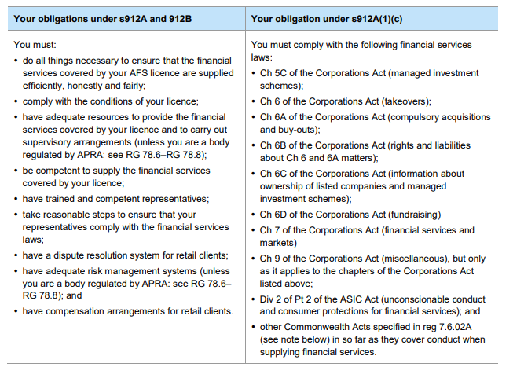
** a ‘likely breach’ occurs when the Licensee is longer able to comply with an obligation.
ASIC’s Form “Notification by an AFS Licensee of a Significant Breach of a Licensee’s Obligations” (FS 80) can be used to communicate a significant Breach to ASIC. Other forms may be used. (RG78.23(b))
Only ‘significant’ breaches need be reported. Significance is determined by:
- frequency of similar previous breaches
- the impact of the breach on the licensee's ability to provide the financial services
- the extent to which the breach indicates that the licensee's arrangements to ensure compliance with those obligations is inadequate
- the actual or potential loss to clients or the licensee itself.

ASIC’s Regulatory Guide “Breach Reporting by AFS Licensees” (RG 78) examples breaches that may not be significant: (table 4)
  - Inappropriate advice is provided but it is an isolated incident
  - Immaterial errors
  - Errors of advice or implementation that are not systemic failures

ASIC regards it as a matter of Best Practice that a Breach Register be kept. (RG78.20)
Contents should include:
  - Date of Breach
  - Description of the Breach
  - Why the breach is significant
  - How the breach was identified
  - How long the breach lasted
  - Information about an authorised representative
  - How the breach has been rectified
  - Future Steps to Ensure Compliance
ASIC’s possible responses:
  - Acknowledgement
  - Request for more information (if needed)
  - Decision
  - Notification of Decision to Licensee
  - Addressing compliance issues with the Licensee
  - Formal surveillance of the Licensee
  - Criminal, civil or administrative actions
Other Relevant Regulatory Guides:
RG 98 Licensing: Administrative action against financial service providers
RG 100 Enforceable undertakings
Other Registrable issues:
RG 182 Managing Conflicts of Interest
RG 182 Dollar disclosure

Interprac’s Operational Response
- InterPrac requires ARs to record significant breaches in the Practice Breach Register and to use that to notify the Licensee
InterPrac’s Breach Register then captures that information in a Licensee register.

- Non-significant breaches are recorded in a Practice Incident Register and it is used to notify the Licensee
- Conflicts of Interest (COI) are recorded in the Practice COI register and it is used that to notify the Licensee

- Soft Dollar & Gits are recorded in Practice registers and they are used to notify the Licensee

- The Licensee determines if a Breach is not significant. In that instance. Remedial actions, inclusive of education and training, will be undertaken.
(refer: PROVIDING OVERSIGHT OF ADVISERS)

- InterPrac maintains an Opt Out / No Contact Register and it is used to notify the Licensee
Client Surname & Name | Client Contact Number | Client Address if Applicable | Reason for No Contact? | Date | Authorised Rep Name & Code | Auth Rep Telephone | Signature of Compliance Manager

- InterPrac maintains a Complaints Register and it is used to notify the Licensee

(refer: DISPUTE RESOLUTION)

- InterPrac uses Kaplan Ontrack as the Organisation & Practice level Training Register.

ASIC ENFORCEMENT_ TOOLS & PRINCIPLES
Regulatory Guidance
ASIC’s ‘Enforcement Outcomes’ provide insight into important principles employed by the Regulator.
https://asic.gov.au/about-asic/asic-investigations-and-enforcement/asic-enforcement-outcomes/
For example, in REP 625 ‘ASIC enforcement update January to June 2019’
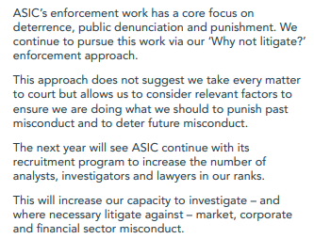
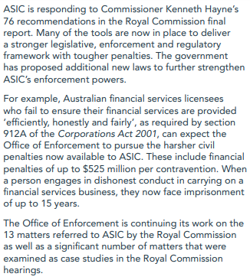
More specifically:
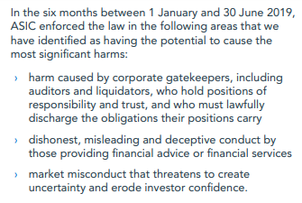

ASIC’s Guide “Client Review and Remediation conducted by Advice Licensees” (RG 256) holds out the following principles in relation to company-wide advice review and systemic remediation:
- determining who are the potentially affected clients;
- designing and implementing the process
- communicating with clients
- providing for external review if the client is not satisfied with the operation of the review and remediation or the result.
A ‘systemic issue’ is defined as actual or potential loss, or detriment, to a number of clients as a result of misconduct or other compliance failure by an advice licensee or its current or former representatives. The impact may be a monetary loss or non-monetary detriment.
(refer: BREACH REPORTING and REGISTERS)
A Licensee must perform any review or remediation in a way that is comprehensive, timely, fair and transparent. (cf. RG 104; RG256 ‘efficiently, honestly and fairly’)
(refer: INTERPRAC LICENSEE OBLIGATIONS)

Interprac’s Operational Response

Not Applicable

FASEA CODE OF ETHICS

VALUES & STANDARDS
Regulatory Guidance
FASEA is an acronym of Financial Adviser Standards and Ethics Authority. It provides standards of professional conduct, education pathways for existing and new advisers, guidance on on-the-job training for new advisers and requirement for maintaining ongoing knowledge and skills.
https://www.fasea.gov.au
From 1 January 2020, a Code of Ethics, informed by professional Values, came into effect.
https://www.fasea.gov.au/wp-content/uploads/2019/10/FASEA-Financial-Planners-and-Advisers-Code-of-Ethics-2019-Guidance-1.pdf
The professional Values that underlie the Code are:

Trustworthiness
Competence
Honesty
Fairness
Diligence

The Code is expressed in 12 Standards:
Ethical Behaviour
Std 1: You must act in accordance with all applicable laws, including this Code, and not try to avoid or circumvent their intent.
Std 2: You must act with integrity and in the best interests of each of your clients.
Std 3: You must not advise, refer or act in any other manner where you have a conflict of interest or duty.
Client Care
Std 4: You may act for a client only with the client’s free, prior and informed consent. If required in the case of an existing client, the consent should be obtained as soon as practicable after this Code commences.
Std 5: All advice and financial product recommendations that you give to a client must be in the best interests of the client and appropriate to the client’s individual circumstances.
You must be satisfied that the client understands your advice, and the benefits, costs and risks of the financial products that you recommend, and you must have reasonable grounds to be satisfied.
Std 6: You must take into account the broad effects arising from the client acting on your advice and actively consider the client’s broader, long-term interests and likely circumstances.
Quality Process
Std 7: The client must give free, prior and informed consent to all benefits you and your principal will receive in connection with acting for the client, including any fees for services that may be charged. If required in the case of an existing client, the consent should be obtained as soon as practicable after this code commences.
Except where expressly permitted by the Corporations Act 2001, you may not receive any benefits, in connection with acting for a client, that derive from a third party other than your principal.
You must satisfy yourself that any fees and charges that the client must pay to you or your principal, and any benefits that you or you principal receive, in connection with acting for the client are fair and reasonable, and represent value for money for the client.
Std 8: You must ensure that your records of clients, including former clients, are kept in a form that is complete and accurate.
Std 9: All advice you give, and all the products you recommend, to a client must be offered in good faith and with competence and be neither misleading nor deceptive.
Professional Commitment
Std 10: You must develop, maintain and apply a high level of relevant knowledge and skills
Std 11: You must cooperate with ASIC and monitoring bodies in any investigation of a breach or potential breach of this Code.
Std 12: Individually and in cooperation with peers, you must uphold and promote the ethical standards of the profession and hold each other accountable for the protection of the public interest.

Interprac’s Operational Response
(refer: INTERPRAC’s BUSINESS PRINCIPLES: TBA)

(refer: COMPLIANCE SCHEMES)

CODE MONITORING
(refer: DISPUTE RESOLUTION)
(refer: COMPLIANCE SCHEMES)

CLIENT DEALINGS

BEST INTERESTS DUTY
Regulatory Guidance
s961 of the Corporations Act provides:
The advice provider must act in the Best Interests of the client in relation to the advice and must evidence the following behaviours:
- Identify the objectives, financial situation and needs of the client
- Identify the subject matter of the advice that has been sought by the client (whether explicitly or implicitly)
- Where it was reasonably apparent that information relating to the client's relevant circumstances was incomplete or inaccurate, make reasonable inquiries to obtain complete and accurate information;
- Self-assess whether the provider has the expertise required to provide the client advice on the subject matter sought and, if not, decline to provide the advice;
- Conduct a reasonable investigation into any applicable financial products that might achieve those of the objectives and meet those of the needs of the client that would reasonably be considered as relevant to advice on that subject matter
- Assess the information gathered in the investigation;
- Base all judgements in advising the client on the client's relevant circumstances;
- Take any other step that, at the time the advice is provided, would reasonably be regarded as being in the best interests of the client, given the client's relevant circumstances.

ASIC’s Regulatory Guide (RG 175) identifies the obligations of the Best Interests Duty with the Safe Harbour Steps.
(refer: FINANCIAL PRODUCT ADVISERS: CONDUCT AND DISCLOSURE)
(refer: LIMITED ADVICE LICENSEES)
Corporation regulations Part 7.7A Div 2: 05-07 “Best Interests Obligations and remuneration” exempts the safe harbour provisions for basic banking products, general insurance products & consumer credit insurance.
Note: The equivalent duty for securities trading is ‘Best Execution’ (Best Outcome) obligation.
(RG 265 section G; especially RG 265.137,139; further referencing ‘ASIC Market Integrity
Rules (Securities Markets) 2017’ Part 3.8.1)

Interprac’s Operational Response
(refer: BUSINESS PRINCIPLES: BEST INTERESTS DUTY)

FINANCIAL SERVICES GUIDE
Regulatory Guidance
s941 A,D of the Corporations Act provide that the FSG is given to the client as soon as practicable after it becomes apparent to the advice provider that the financial service will be, or is likely to be, provided to the client. It must in any event be given to the client before the financial service is provided.
If the client expressly instructs that they require the financial service to be provided immediately, or by a specified time, and it is not reasonably practicable to give the FSG ahead of the service being provided, the Adviser must give the client a statement before the service is provided.
This statement must include:
- the information that would be required to be in the FSG
- other information particularly relevant to the financial service to be provided.
The client must then be given the Financial Services Guide within 5 days after being given the statement, or sooner if practicable.
s 941 B, s 942 E require the authorising licensee to have approved its distribution.
ASIC’s Class Order (CO 12/417) requires that the information in a Financial Services Guide must be up to date when it is given to the client. S 941 E, s 943 A allow a Supplementary Financial Services Guide containing updated information when a FSG is out of date.
s 941 C states that an Adviser need nor provide the FSG if the financial service is General Advice.
s 942 A states that the full terminology “Financial Services Guide” must be on the cover; but can be abbreviated elsewhere.
s 942 B lists the information that must be disclosed about the Licensee
s 942 C lists the information that must be disclosed about the Authorised Representative
s 942 D allows that the FSG may be two documents given at the same time.
RG 221 provides for FSGs to be delivered electronically and potentially incorporate video, audio, interactivity and animation (RG 221.76).
FSGs are exempt from showing both % & dollar equivalent amounts (RG 182.8 (a))
ASIC’s Regulatory Guide ‘Licensing: Financial product advisers—Conduct and disclosure’ (RG 175) details:
- The Obligation to prepare and provide an FSG
- When an FSG is to be provided?
esp. as soon as practicable; time critical cases;
Exemptions apply to non-retail clients (RG 175.104 (b)) and certain products (esp. CMTs, basic deposit products)
- Necessary FSG information
esp. remuneration, commission (RG175.112) ; fee ranges, rates, comparisons, simple tables and formulas can all be included
- How the FSG must be provided?
- How the FSG obligations apply to secondary services
ie provided via an intermediary (RG 175.129)
- When can a FSG be combined with a PDS
- Record-keeping obligations that apply to FSGs
esp. Licensee to keep copies of FSGs
- Other key aspects of the FSG regime
esp. a FSG can cover more than one entity (CAR, AR) (RG175.150); an entity may have more than one FSG (RG175.151)
Words such as ‘independent, impartial, unbiased’ have a restricted meaning.
Defective FSGs may attract civil penalties. (RG175.153 (b))

Interprac’s Operational Response
Preparing and Authorising the FSG
(refer: INTERPRAC’s BUSINESS PRINCIPLES: MARKETING AND CLIENT DOCUMENTS)

Failure to Provide FSG
(refer: BREACH REPORTING AND REGISTERS)

CONFLICT OF INTEREST
Regulatory Guidance
Corporations Act 2001 s 963A defines Conflicted Remuneration to cover any benefit, monetary or non-monetary, that could reasonably be expected to influence the choice of a financial product or the product advice offered.
ASIC’s Regulatory Guide ‘Conflicted and Other banned Remuneration’ (RG 246) states that it aims to more closely align the interests of advice providers with the interests of Clients.
The ban on conflicted remuneration does not apply to some benefits given to an AFS licensee or its representatives under arrangements entered into before 1 July 2013 (Application Date); ‘grandfathered’.
This exemption also applies if a new arrangement, essentially the same as the previous arrangement, is entered into after the Application Date (RG 246.277(b)); ‘renewed’.
Compliance with conflicted and banned remuneration provisions was mandatory post 1 July 2013 (Application Day) excepting life insurance products.
An exception occurs if the arrangement was entered into before the Application day but results in a new product acquisition post 1 July 2014.
(refer: FEE FOR SERVICE / OPT IN)
Corporations Regulations 2001 Div 4 Subdivision 1 “Conflicted Remuneration” (REG 7.7A.11A-D) provides that certain Insurance related benefits will be conflicted remuneration if:
  - tied to the value of the insured benefit
  - tied to the number of insurance products
  - they are reasonably expected to influence an advice provider to give or withhold product information to a retail client
  - they increase disproportionately in subsequent policy years (7.7A.11C (b)(1))
  - clawback arrangements do not apply
  - the value of the benefit is material (>$300)
Corporations Regulations 2001 Div 4 Subdivision 2 “Conflicted Remuneration” (REG 7.7A.12D) provides that brokerage related benefits will be conflicted remuneration if:
  - It is more than 100% of the brokerage fee
RG246.239-244 extends the definition of conflicted remuneration to include:
  - Volume based shelf-space fees
  - Asset based fees on borrowed amounts
  - Benefits paid under a scheme designed to avoid the application of conflicted remuneration provisions (RG246.258ff)
Contracted client Fees are never conflicted remuneration (REG 7.7A.12EF)
Grandfathered benefits can be transferrable (RG246.228-235).
Interprac’s Operational Response
Monitoring and Enforcement - Conflict of Interest Register
(refer: BREACH REPORTING AND REGISTERS)

Standard Statement of Advice Template Disclosure
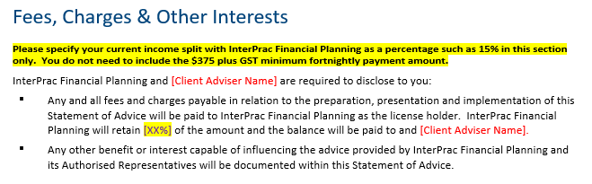

Education and Training
(refer: INTERPRAC’s BUSINESS PRINCIPLES: BEST INTERESTS DUTY)
(refer: INTERPRAC’s BUSINESS PRINCIPLES: ADVICE PROCESS)
(refer: INTERPRAC’s BUSINESS PRINCIPLES: SMSF ADVICE)
(refer: INTERPRAC’s BUSINESS PRINCIPLES: BREACH AND INCIDENT REPORTING)

Organisational Conflicts of Interest Register
InterPrac retains an organisational register.
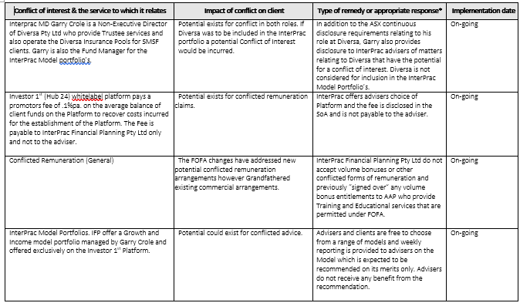

FEE FOR SERVICE / OPT IN
Regulatory Guidance
Corporations Act 2001 s 962 provides:
- An ongoing fee arrangement (OFA) has the following characteristics
  - Relates to personal advice
  - Entered into under a contract, agreement, understanding or scheme
  - Whereby a fee is to be paid for a period exceeding 12 months
  - The advice recipient can opt to discontinue the arrangement at any time; waiving any ongoing fee obligation for future advice/services
  - Unless formally reassigned, the AR who enters into the arrangement is the ‘fee recipient’ and bears the obligation to provide service
  - It terminates unless the client completes a Renewal Notice.
Client payments received once the OFA terminates need not be refunded. (s 962F (3))

The definition excludes a fixed fee that is simply paid by instalments

- ASIC can exempt persons from the Opt In regime if bound by an approved Code of Conduct published in the Government Gazette.

- The day the OFA is entered into is the Application Day. An Application Day cannot pre-date 1 July 2013.
(refer: CONFLICT OF INTEREST)
- Within 60 days after the Disclosure Day (each 12month anniversary of the original or new OFA), a Fee Disclosure Statement must be supplied. It must contain:
  - each ongoing fee ($) paid under the arrangement by the client in the previous year, expressed in Australian dollars
  - information about the services that the client was entitled to receive from the current, and any previous, fee recipient under the arrangement during the previous year;
  - information about the services that the client received from the current and any previous fee recipient under the arrangement during the previous year
Should a FDS not be supplied, it may attract a civil penalty.

- Within 60 days after each second (24month) anniversary of the original or new OFA, a Renewal Notice must be supplied. It must be accompanied by the FDS.
It must contain the following statements:
  - the client may renew the arrangement by giving the current fee recipient notice, in writing, of the election
  - the arrangement will terminate, and no further advice will be provided or fee charged under it, if the client does not elect to renew the arrangement
  - the client will be taken to have elected not to renew the arrangement if the client does not give the current fee recipient notice, in writing, of an election to renew before the end of the renewal period
  - that the renewal period is a period of 30 days beginning on the day on which the renewal notice and fee disclosure statement is given to the client.
Should the client cancel the OFA by notifying the fee recipient, in writing, ahead of the conclusion of the 30 day period, the OFA terminates on the date this notification is given.
- Should an OFA be cancelled, continuing to charge an ongoing fee can attract a civil penalty.

- Should an OFA be cancelled, the obligation to provide service terminates

Corporations Regulations 2001 Div 3 “Charging Ongoing Fees to Clients” (REG 7.7A.10,11) provides that an Ongoing Fee Arrangement cannot be a ‘product fee’.
A product fee is a fee for the administration, management or operation of a financial product that is charged to a retail client to which the product is issued by the issuer of the product; is a fee that is a cost recovery for financial product advice. It need not be included in a FDS.
Interprac’s Operational Response
Fee Disclosure Statement
InterPrac provides a Fee Disclosure Statement template.

Renewal Notice
InterPrac provides a Renewal Notice template.

Ongoing Fee Arrangements - Education and Training
InterPrac provides a “Fee Disclosure Statement (FDS) Renewal Notice Guide” on the Adviser Resource Centre website:

(refer: INTERPRAC’s BUSINESS PRINCIPLES: FEE DISCLOSURE STATEMENT AND RENEWAL NOTICE)

Ongoing Fee Arrangements _ Monitoring and Enforcement
(refer: BREACH REPORTING AND REGISTERS)

AML / CTF
Regulatory Guidance
AUSTRAC (Australian Transaction Reports and Analysis Centre) monitors & regulates anti-money laundering and counter-terrorism financing (AML/CTF) activities in Australia that originate domestically or internationally.
Unless exempted, AFSL licensee must enrol with AUSTRAC within 28 days of commencing as Licensees. http://www.austrac.gov.au/chapter-4-enrolment-requirements#required
AML/CTF Act contains the requirement that reporting entities (AFSL Licensee) must develop and maintain a written AML/CTF programme.
A programme includes:
  - risk assessment of the business conducted by the entity. This assessment must be reviewed and updated periodically
  - approval and ongoing oversight by boards (where appropriate) and senior management
  - appointment of an AML/CTF compliance officer
  - regular, independent review
  - an employee due diligence program
  - an AML/CTF risk awareness training program for employees
  - policies and procedures for the reporting entity to respond to and apply AUSTRAC feedback
  - systems and controls to ensure the entity complies with its AML/CTF reporting obligations
  - ongoing customer due diligence procedures, which provide for the ongoing monitoring and management of risks.
Procedures should exist to:
  - identify customers (retail and wholesale advice clients) so the reporting entity can be reasonably satisfied of an individual’s true identity
  - collect and verify that information.
http://www.austrac.gov.au/chapter-6-amlctf-programs
Licensee Reporting obligations include:
  - Suspicious Matters
http://www.austrac.gov.au/chapter-7-amlctf-reporting-obligations

A Suspicious Matter Report (SMR) is required if the reporting entity forms a suspicion on reasonable grounds that:
  - a person (or their agent) is not the person they claim to be
  - there is an evasion (or attempted evasion) of a tax law
  - there’s an offence against a Commonwealth, state or territory law
Or the matter may assist in enforcing:
  - the Proceeds of Crime Act 2002 (or regulations under that Act)
  - a state or territory law that corresponds to that Act or its regulations
http://www.austrac.gov.au/suspicious-matter-reports-smrs
Further helpful discussion, from the perspective of reporting to ASIC re. whether a matter is suspicious, is found in ASIC’s Regulatory Guide “Guidance on ASIC market integrity rules for participants of securities markets’ (RG 265 section H):
“In Queensland Bacon Pty Ltd v Rees (1966) 115 CLR 266, Kitto J described (at 303) a suspicion of something as being:
… more than a mere idle wondering whether it exists or not; it is a positive feeling of actual apprehension or mistrust amounting to a ‘slight opinion, but without sufficient evidence’.” (RG 265.259)

Interprac’s Operational Response
Given that InterPrac does not directly deal with retail or wholesale clients, Authorised Representatives are co-opted to report to the Licensee so that the Licensee may, in turn, report valid matters to AUSTRAC.
AML/CTF Programme
InterPrac provides the following guidance tools to its Authorised Representatives on its Adviser Resource centre website:
“AML Guidance”
“Financial Crime Red Flags – An Austrac Guide for Financial Planners”
Also:
(refer: INTERPRAC’s BUSINESS PRINCIPLES: AML/CTF REQUIREMENTS)

InterPrac provides the following ID tools to its Authorised Representatives on its Adviser Resource centre website:
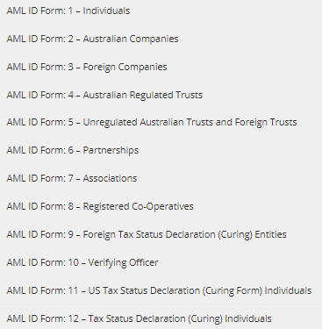

Suspicious Matter Reporting
InterPrac provides the following guidance tools to its Authorised Representatives on its Adviser Resource centre website:
“Financial Crime Red Flags – An Austrac Guide for Financial Planners”

Monitoring
As part of the Site Audit process, client files are routinely checked by the Compliance Staff for correct AML/CTF documentation.

DISPUTE RESOLUTION
Regulatory Guidance
- In July 2020, ASIC published RG 271 “Internal Dispute Resolution”.
Scope: AFSLs, unlicensed product issuers, unlicensed secondary sellers, trustees of regulated superannuation funds (other than SMSFs), trustees of ADFs, RSAs, Australian credit licensees and unlicensed COI lenders.
- ASIC’s Regulatory Guide “Licensing: Internal and External Dispute Resolution” (RG 165) provides that AFSL Licensees must have dispute resolution system covering complaints from retail clients:
  - Internal (complying with ASIC standards)
  - External (ASIC approved)
Credit Licensees have similar responsibilities (s 47 National Consumer Credit Protection Act 2009) and Representatives must also be separately registered.
Internal Schemes (IDR) _ RG 271 _ effective 5 October 2021
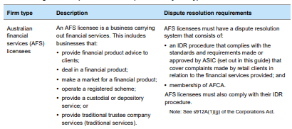
The complaint lodgement process must be free for complainants.
Complaints include:
(a) posts (that meet the definition of ‘complaint’ set out in RG 271.27) on a social media channel or account owned or controlled by the financial firm that is the subject of the post, where the author is both identifiable and contactable
(b) an objection to a proposed decision about how and to whom to pay a superannuation death benefit distribution;
(c) complaints about a matter that is the subject of an existing remediation program or about the remediation program itself (e.g. delays, lack of communication);
(d) complaints about the handling of an insurance claim (e.g. excessive delays or unreasonable information requests)

Responding:
A financial firm should acknowledge receipt of each complaint promptly acknowledging within 24 hours (or one business day) of receiving it, or as soon as practicable.
The formal response must be provided up to 30 days from the date of lodgement**:
(a) final outcome of their complaint (either confirmation of actions taken by the firm to fully resolve the complaint or reasons for rejection or partial rejection of the complaint);
(b) their right to take the complaint to AFCA if they are not satisfied with the IDR response
(c) the contact details for AFCA
** unless the complaint is complex or there are circumstance beyond the control of the respondent.
Remedies may include:
(a) an explanation of the circumstances giving rise to the complaint;
(b) an apology;
(c) provision of assistance and support;
(d) a refund or waiver of a fee or charge;
(e) a goodwill payment;
(f) a payment of compensation;
(g) a waiver of a debt;
(h) replacing damaged or lost property;
(i) correcting incorrect or out-of-date records;
(j) repairing physical damage to property;
(k) changing the terms of a contract;
(l) ceasing legal or other action that may cause detriment; and
(m) undertaking to set in place improvements to systems, procedures or products
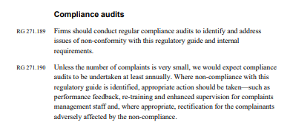
Internal Schemes (IDR) _ RG 165
Maximum IDR Timeframes
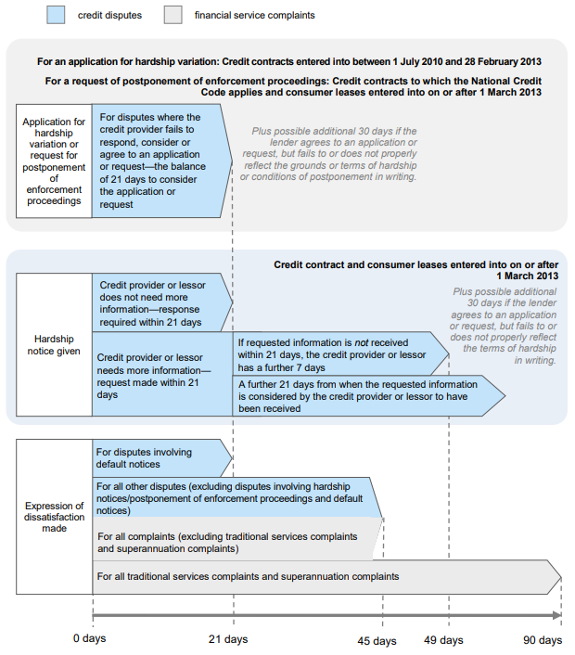
The IDR process must document:
- Procedures & policies
  - receiving complaints or disputes
  - investigating complaints or disputes
  - responding to complaints or disputes within appropriate time limits
  - referring unresolved complaints or disputes to an EDR scheme
  - recording information about complaints or disputes
  - identifying and recording systemic issues
- Remedies

The Australian Standard (AS ISO 10002-2006) sets the following Guiding Principles (RG 165, Table 2; ASIC Class Order 10/250)

  - Visibility
  - Accessibility
  - Responsiveness
  - Objectivity
  - Free of Charge
  - Confidentiality
  - Customer focussed
  - Accountability
  - Continually self-assessing and improving
  - Organisational commitment
  - Sufficient Resourcing
  - Protecting personal information
  - Analyse and evaluate complaints

External Schemes (EDR)
ASIC’s Regulatory Guide “Oversight of the Australian Financial Complaints Authority” (RG 267) sets general considerations for an EDR scheme:
  - accessibility
  - independence
  - fairness
  - efficiency and effectiveness
  - accountability
Australian Financial Complaints Authority (AFCA) aggregates the previously separate FOS (financial planning), CIO (credit licensees), SCT (superannuation; excl. SMSF). It services consumers (individuals), small businesses (less than 100 employees), registered charities and clubs (less than 100 employees) that carry on a business.
To meet ASIC’s requirements (RG267.82), AFCA must:
- be free of charge for complainants
- clearly communicate who is eligible to complain and the complaints it can and cannot deal with
- provide clear reasons for excluding complaints that it determines to be outside jurisdiction
- promote awareness of and access to the scheme
- communicate in a clear, timely and relevant way to consumers, financial firms and other stakeholders and ensure scheme processes are easy to use and understand, and simple to navigate
- clearly set out in the AFCA Rules how and when legal proceedings may be brought in relation to a complaint that has already been lodged with the scheme (see RG 267.101–RG 267.112).

The scope of AFCA’s authority:
- Credit, Loans, Finance
- Insurance
- Banking, payments & transactions
- Investments and financial advice
- Superannuation
https://www.afca.org.au/what-to-expect/complaints-we-consider/
Not within the scope of AFCA’s authority:
- a service or product that is not financial in nature.
- a decision by a financial firm about how to allocate the benefit of a financial service between potential beneficiaries.
- a complaint that raises the same events and facts and is brought by the same person as a complaint previously dealt with by AFCA.
- (typically) a complaint that has already been dealt with by a court, legislative dispute resolution tribunal or a predecessor scheme.
- a small business credit facility of more than $5 million.
- a complaint solely about the investment performance of a financial investment
In its “AFCA Operational Guidelines” processes and principles include:
- AFCA may assist complainants to submit a complaint
- The complaint must involve a financial firm that is an AFCA Member
- AFCA may reject a complaint but will provide reasons and allow a window for the complainant to object
- AFCA will inform the Financial Firms involved in the complaint and provide them with a reasonable opportunity to make submissions
- Superannuation Death Benefits complaints will not be considered by AFCA
- Complaints will be referred to the Financial Firm with a timeframe for resolution or to provide a written response
- More than one Financial Firm can be joined to a complaint
- AFCA will generally share information provided amongst parties to the complaint
- Information obtained through AFCA cannot be used in any subsequent court proceedings
- Information obtained through AFCA is subject to Confidentiality for all parties to the complaint
- Information may pass on information obtained to a Regulator (ASIC, APRA, ATO, OAIC), professional standards body, insolvency practitioner or other compensation mechanism with suitable jurisdiction
- A Determination is subject to: legal principles, industry codes, good industry practice, previous relevant Determinations
- A Determination is not bound by the rules of evidence
- Relevant information can include: expert opinion, documents, contemporaneous notes, pattern(s) of conduct, character information
- A published Determination will not identify the parties to the dispute
- A Determination is final and binding on all parties if accepted by the Complainant within 30 days.
- A Complainant is not bound by a Determination and may bring an action in the courts
- As a result of a specific complaint, AFCA will investigate potential systemic issues
- Systemic issues will be subject to remedial actions; inclusive of an imposed restraint from any reasonably necessary activities
An extensive list of remedies is listed in Section D, inclusive of monetary limits; punitive, exemplary or aggravated damages cannot be awarded.
As required, a Financial Firm may also be required to offset a Complainant’s legal or professional costs or pay interest on a payment to be made to a Complainant. Interest is not taken into account for the maxima applicable to remedies.
While AFCA is handling a complaint, the Financial Firm may not (unless approved):
- recover a debt the subject of the complaint, including enforcement of a default judgment obtained in court
- market or sell assets repossessed in a dispute
- assign any right to recover a debt
- list a default on a Complainant’s credit file
- litigate about matters inconsistent with the agreed resolution
AFCA will generally try to resolve a complaint by informal methods:
- facilitating negotiations between the parties;
- conciliating a complaint
If reasonable attempts to resolve a complaint by these methods do not succeed, AFCA may
- provide a preliminary assessment
- proceed to determine the complaint.
file:///C:/Users/shane.miller/Downloads/AFCA%20-%20Operational%20Guidelines%20to%20the%20Rules%20(5).pdf
Non-advice related, systemic review and remediation
ASIC’s Regulatory Guide “Client Review and Remediation conducted by Advice Licensees” (RG 256) looks at clients suffering loss or detriment as a result of systemic misconduct (decisions, omissions, behaviour) or compliance scheme failures by the Licensee or representatives.
It provides:
- Breach recording
- Proactive internal review when a systemic issue is detected
- Establishment of a process
The process to be comprehensive, timely, fair, and transparent; with clearly defined principles and an appropriate governance structure (including oversight by a senior person).
- The process should also be communicated & be straightforward for an affected Client
- The process be adequately resourced
- Compensation must be available (also see RG 126 “Compensation and Insurance arrangements for AFS Licensees”)
- The process allows an affected client to Opt Out of any review
- The duration of the review period is not typically greater than 7 years
- The process should be free of charge for affected clients
- Representatives must be adequately trained to resolve the systemic problem
In determining a remedy, the aim is to generally place the client in the position they would have been in if the misconduct, or compliance failure, had not occurred.
Speaking at the FPA 2019 Professional Congress, AFCA Deputy Chief Ombudsman, Dr June Smith, said AFCA will take a “…measured and considered approach to interpreting the Code’s provisions”, until the single disciplinary body is established to monitor and enforce the Code.
“AFCA will only assess adviser conduct against the Code where a complaint and the conduct has occurred after 1 January 2020 ….”.
https://riskinfo.com.au/news/2019/12/03/afca-supports-fasea-code/
(refer: FASEA CODE OF ETHICS)

Interprac’s Operational Response
Internal Dispute Resolution
InterPrac’s ARs are required to maintain a Complaints Register.
(refer: BREACH REPORTING AND REGISTERS)
At the Licensee’s discretion, identified disputes may escalate so that the ongoing management is handled by the National Compliance Manager

External Dispute Resolution
InterPrac is a member of AFCA; disputes as managed by the National Compliance Manager

PRIVACY & DATA BREACHES
Regulatory Guidance
The Office of the Australian Information Commissioner (OAIC) regulates the Privacy Act 1988.
This Act encompasses the Australian Privacy Principles (APPs) and the Notifiable Data Breaches (NDB) scheme.

AUSTRALIAN PRIVACY PRINCIPLES
https://www.oaic.gov.au/privacy-law/privacy-archive/privacy-resources-archive/national-privacy-principles
The Principles cover:
- Collection
… what can be collected, collecting from third parties and what individuals should be told about the collection
- Use and Disclosure
… how organisations may use and disclose individuals' personal information; when an organisation may not need an individual's consent to use/disclose personal information; rules about direct marketing
- Information quality & security
… ensuring information is accurate and up-to-date, is managed securely

- Openness
… having a policy on how information is managed, making it accessible
- Access & Correction
… a client’s right of access to their personal information, the right to have information corrected
- Identifiers
… preventing an organisation from adopting an Australian Government identifier for an individual (eg Medicare numbers)
- Anonymity
… organisations must give individuals the opportunity to do business with them without the individual having to identify themselves
- Transborder data flows
… organisations should protect personal information that they transfer outside Australia
- Sensitive information
… relating to health, racial or ethnic background, or criminal records.

APP 1 | Open and transparent management of personal information | Ensures that APP entities manage personal information in an open and transparent way. This includes having a clearly expressed and up to date APP privacy policy.
APP 2 | Anonymity and pseudonymity | Requires APP entities to give individuals the option of not identifying themselves, or of using a pseudonym. Limited exceptions apply.
APP 3 | Collection of solicited personal information | Outlines when an APP entity can collect personal information that is solicited. It applies higher standards to the collection of sensitive information.
APP 4 | Dealing with unsolicited personal information | Outlines how APP entities must deal with unsolicited personal information.
APP 5 | Notification of the collection of personal information | Outlines when and in what circumstances an APP entity that collects personal information must tell an individual about certain matters.
APP 6 | Use or disclosure of personal information | Outlines the circumstances in which an APP entity may use or disclose personal information that it holds.
APP 7 | Direct marketing | An organisation may only use or disclose personal information for direct marketing purposes if certain conditions are met.
APP 8 | Cross-border disclosure of personal information | Outlines the steps an APP entity must take to protect personal information before it is disclosed overseas.
APP 9 | Adoption, use or disclosure of government related identifiers | Outlines the limited circumstances when an organisation may adopt a government related identifier of an individual as its own identifier, or use or disclose a government related identifier of an individual.
APP 10 | Quality of personal information | An APP entity must take reasonable steps to ensure the personal information it collects is accurate, up to date and complete. An entity must also take reasonable steps to ensure the personal information it uses or discloses is accurate, up to date, complete and relevant, having regard to the purpose of the use or disclosure.
APP 11 | Security of personal information | An APP entity must take reasonable steps to protect personal information it holds from misuse, interference and loss, and from unauthorised access, modification or disclosure. An entity has obligations to destroy or de-identify personal information in certain circumstances.
APP 12 | Access to personal information | Outlines an APP entity’s obligations when an individual requests to be given access to personal information held about them by the entity. This includes a requirement to provide access unless a specific exception applies.
APP 13 | Correction of personal information | Outlines an APP entity’s obligations in relation to correcting the personal information it holds about individuals.

The Commissioner may undertake a Commissioner Initiated Investigation (CII) or an Assessment (s 33C) into an agency or private sector organisation.
Under s 52 of the Privacy Act, the Commissioner can make Determinations on privacy complaints where conciliation has not resolved the matter; or in relation to a CII.
Under s 33E, the Commissioner can accept Enforceable Undertakings or progress court action.

NOTIFIABLE DATA BREACHES SCHEME
https://www.oaic.gov.au/privacy-law/privacy-act/notifiable-data-breaches-scheme
Organisations are required to notify affected individuals and the Office of the Australian Information Commissioner (OAIC) when a data breach is likely to result in serious harm to individuals whose personal information is involved in the breach.
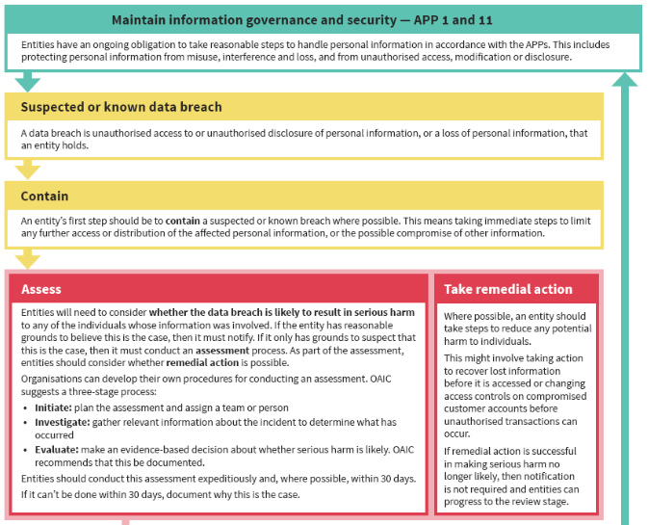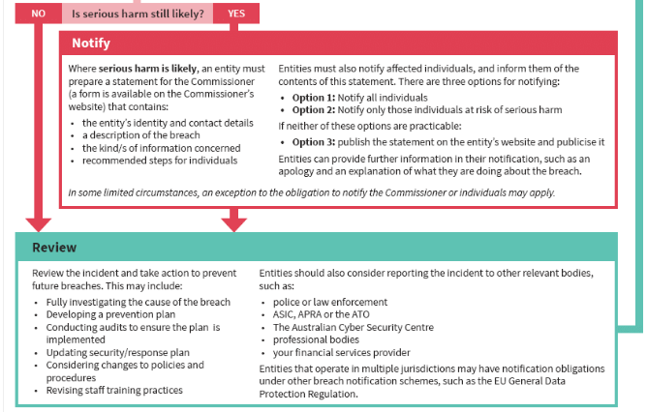

Interprac’s Operational Response

InterPrac publishes a Privacy Policy that is mandatory for ARs to reference with clients.
National Privacy Principles
<TBA>

National Data Breach Scheme
<TBA>

CLIENT ADVICE

GENERAL ADVICE AND FACTUAL INFORMATION
Regulatory Guidance
ASIC’s Regulatory Guidance “Giving Information, General Advice and Scaled Advice” (RG 244 section C) provides Guidance on the provision of General Advice:
As a general rule, if you carry on a business in Australia of giving general advice to clients that is a financial service, you must hold an AFS licence with an authorisation to give general advice, or be an authorised representative of such a licensee, unless an exemption applies. (RG 244.37)
You can use personal information about a client to give general advice that is more relevant to a client. However, you must ensure that you do not, in fact, consider the client’s relevant circumstances when you prepare and give the general advice. If you do, you will be giving personal advice. You cannot avoid this by giving a general advice warning to the client. (RG244.47)
Section 949A(2) of the Corporations Act 2001 requires a General Advice warning as appropriate.
It must comprise:
- the advice has been prepared without taking account of the client's objectives, financial situation or needs; and
- the client should, before acting on the advice, consider the appropriateness of the advice, having regard to the client's objectives, financial situation and needs; and
- if the advice relates to the acquisition, or possible acquisition, of a particular financial product
  - the client should obtain a Product Disclosure Statement (see Division 2 of Part 7.9) (or Information Statement as appropriate) relating to the product
  - and consider the Statement before making any decision about whether to acquire the product
This warning must accompany the advice and be in the same medium as the advice was given.
ASIC’s Consultation Paper “Repetition of the General Advice Warning” (CP 71) indicates ASIC’s approach to enforcement of the General Advice Warning. It need not be provided more than once in a single document, during the one phone call or in the one meeting.
---()---
ASIC’s Regulatory Guidance “Giving Information, General Advice and Scaled Advice” (RG 244 section B) distinguishes factual information from General or Personal Advice.
However, it may be interpreted to be personal advice if “… it is presented in a way that is intended to, or can reasonably suggest or imply an intention to, make a recommendation about what a client should do.” (RG 244.29, cf. RG 36.31)
To avoid such interpretation:
  - it must be clarified at the outset that this is factual information; and
  - the information is not intended to imply any recommendation or opinion about a financial product
Personal information of the client’s circumstances may set a context for the factual information if it simply ensures the ‘relevance’, or not, of giving that information. (RG 244.35-36)

Interprac’s Operational Response
(refer: FINANCIAL PRODUCT ADVISERS: CONDUCT AND DISCLOSURE)
(refer: ONBOARDING ADVISERS)
(refer: FINANCIAL SERVICES GUIDE)

Education and Training
(refer: INTERPRAC’s BUSINESS PRINCIPLES: TYPES OF ADVICE)

Monitoring & Enforcement
(refer: BREACH REPORTING AND REGISTERS)

HOLISTIC AND SCALED ADVICE
Regulatory Guidance
ASIC’s Regulatory Guidance “Giving Information, General Advice and Scaled Advice” (RG 244 section D) & “Licensing: Financial Product Advisers – Conduct & Disclosure” (RG 175) provide Guidance on the provision of Scaled Advice:
“It is important to note that the same rules apply to all personal advice on a particular topic: there are not two sets of rules one for ‘comprehensive’ advice, and one for ‘scaled’ advice that is more limited in scope”. (cf. RG 175.393)
All advice is scaled to some extent; it can be ‘scaled up’ or ‘scaled down’. It must meet the Best Interests duty and must be monitored by Licensees (RG 175.417)
Consumers who seek financial advice, including scaled advice, expect that the advice provided will leave them in a better position. (RG 244.62) Advice may not be product specific.
The adviser can use judgement to limit the scope of advice; but it must still address the client’s relevant circumstances. Fact Finding may be more limited. (RG249.72)
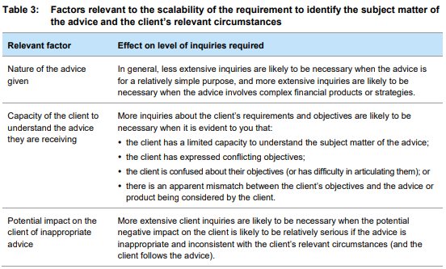
Good practice is to give a simple and accurate explanation about why the scope of the advice has been limited. (RG 244 Table 2)
It is unlikely that personal advice will meet the Best Interests duty if the client does not understand any of the limitations or qualifications that apply to the advice. (RG 244.92)
Advice can be limited to matters on which the advice provider is competent to advise. (RG175.380)
A Modified Best Interests Duty may apply if the advice sought by the client relates only to a basic banking product, general insurance product or consumer credit insurance. (RG 175 Table 6). The proof of requirements of s 961 B(2)(d)-(g) is not required:
- specific expertise
- reasonable investigation into a range of financial products
- considered all relevant circumstances
- to have taken any other step that might be relevant to the client’s wider circumstances

Interprac’s Operational Response
(refer: INTERPRAC’s BUSINESS PRINCIPLES: TYPES OF ADVICE)
(refer: INTERPRAC’s BUSINESS PRINCIPLES: BEST INTERESTS DUTY)
(refer: INTERPRAC’s BUSINESS PRINCIPLES: ADVICE DOCUMENTATION)

Advice Templates
InterPrac provides a Risk Only advice template
InterPrac provides a SMSF Establishment Only advice template
(refer: LIMITED ADVICE LICENSEES)

FINANCIAL PRODUCT ADVICE, DEALING AND ARRANGING
Regulatory Guidance
ASICS’s Regulatory Guide “Licensing” Financial Product Advice and Dealing” (RG 36) defines the following terms:
- Financial Product Advice
As per s 766B of the Corporations Act: advice that influences a decision regarding a product or class of products
- Dealing
As per s766C(1) of the Corporations Act:
  - applying for or acquiring a financial product;
  - issuing a financial product
  - underwriting securities or managed investment schemes
  - varying a financial product
  - disposing of a financial product
- Arranging
A process that brings into effect a dealing. Arranging can occur if the intermediary(s):
  - involvement is sufficiently important that the dealing could not occur
  - adds significant value for the person for whom the intermediary acts
  - One receives benefits from the person for whom one is acting
Dealing or Arranging require an intermediary to hold an AFS Licence unless solely providing services to wholesale clients. Licensee obligations are detailed in RG 36.94-100.
Dealing is not:
  - acting for oneself <unless, as a product issuer, you deal in your own products>
  - preparing a document of registration or transfer in order to complete administrative tasks on instructions from a person
  - sub-underwriting
  - the work typical of a clerk or cashier
  - disposing of a product subject to a mortgage
  - acting as a trustee of a non-public superannuation entity
  - an employer paying super contributions for an employee
  - an employer managing an employee share scheme

A SOA must be given to a client before arranging for a financial product to be issued to the client: s946C(1). (RG 175.163)

Interprac’s Operational Response

InterPrac Financial Planning provides Financial Product Advice via its Authorised Representatives.
InterPrac is licensed to deal and arrange in financial products eg. Hub 24, Investor1st

PREVET PROCESS
Regulatory Guidance
(refer: PROVIDING OVERSIGHT OF ADVISERS)
(refer: LIMITED ADVICE LICENSEES)
(refer: ONBOARDING ADVISERS)

Interprac’s Operational Response
InterPrac requires newly onboarded Representatives to submit the first 5 SoA’s they produce for review by the Compliance Team before being presented to a retail client. This is the PreVet Process.
As required by the Compliance Team, the number of SoAs may be extended indefinitely until Representatives unambiguously demonstrates in writing their Best Interests duty & the Licensee is satisfied that its template stylistic requirements are mastered.

(refer: INTERPRAC’s ‘DEMONSTRATING BEST INTEREST IN THE SoA _GUIDELINES’)
(refer: INTERPRAC’s BUSINESS PRINCIPLES: ADVICE DOCUMENTATION)

Enforcement and Monitoring
A Representative who cannot meet the requirements of the PreVet Process may have their authorisation revoked
(refer: REVOCATION OF ADVISERS)

POSTVET REVIEWS
Regulatory Guidance

Interprac’s Operational Response
Especially in regards the compulsory submissions (Business Principles_SMSF) ie. first 2 SMSFs, All LRBAs, All Gearing:
- In PreVet … style & substance bear equal weight and resubmissions are likely the norm.
- In PostVet … substance bears most weight; style can be raised as valuable; resubmissions only in the riskiest situations.
The difference occurs because:
- PostVet advisers may have been with us for years … reflexive ‘resubmission’ may not seem to acknowledge that
- in the case of LRBA (say), we’re calling these in because of the intrinsic risk they bear; that’s the prime focus.
So, the PostVet key matters are:
- Is the advice technically correct?
- Is the advice ‘Appropriate’. The client is in a better position in respect of their objectives and financial/broader circumstances
Then advice on further supporting the Best Interest Duty (stylistic matters) may be offered in the spirit of strong encouragement.
Further resubmissions, only as the adviser wishes or firm conviction requires.
---------------------------------------------------------
Further To: “Is the advice technically correct?”
- Is the structure of the of the proposed SMSF correct/unambiguously/explicitly describing, in a tailored fashion:
- Trustee structure, roles and responsibilities inc. estate planning matters; fund continuity in the event of a trustee’s death
- Investment strategy (incl. explicit asset allocation for portfolio advice & evidencing insurance ‘considerations’ for member’s)
- First year costs of establishment (incl. 3rd party costs)
- Insurance _ impact upon retirement savings and liquidity
- Are portfolio recommendations aligned to Investment Strategy (+/- 10%)
- Income streams (sustainability, adequacy, estate planning matters, TBA/TBC)

- Is the structure of the proposed LRBA correct/unambiguously/explicitly described, in a tailored fashion:
- Nil specific ‘loan provider’ recommendations
- Gearing ratio (as per 3rd party provider’s business rules); related party loans LVR; <= 70%
- First year costs of establishment, if known by the adviser in advance
- Impact upon operating liquidity; as relevant, income streams
- Estate planning considerations (paying down the loan)

- Property purchase (implications only; not a specific recommendation)
These matters may assume a greater or lesser relevance depending upon the SoA but should provide some prompts.
- Strongly advised Style (risk management) matters that demonstrate Best Interest Duty
- FASEA #5; ensure the client ‘understands’; benefits risks, costs
- FASEA #6; broader long-term interest and circumstances
- FASEA #9; all advice offered competently
- FASEA #7; fees are fair & reasonable

STATEMENT OF ADVICE
Regulatory Guidance
Sections 944A & 946A of the Corporations Act 2001, requires that a Statement of Advice must be prepared when personal advice, from a Licensee or Authorised Representative, is provided to a retail client.
ASIC’s Regulatory Guide “Example Statement of Advice: Scaled Advice for a New Client” (RG 90) evidences ASIC’s approach to the format and contents of a SoA
(refer: HOLISTIC AND SCALED ADVICE)
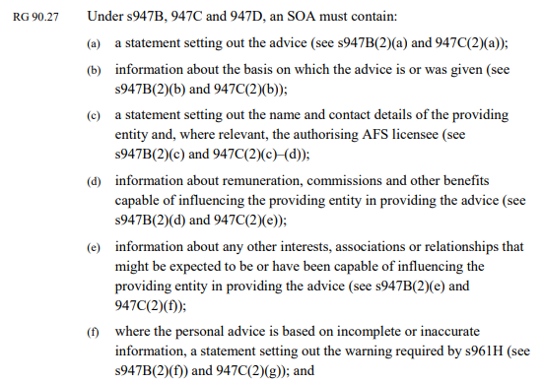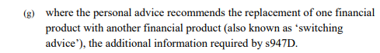
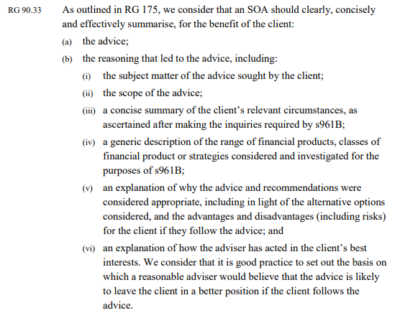
ASIC’s Regulatory Guide “Dollar Disclosure” (RG 182) requires costs, fees, charges, expenses, benefits & interests to be disclosed in dollars in a SoA.
ASIC’s Regulatory Guide “Facilitating Digital financial Services Disclosures” (RG 221) encourages innovative formatting, delivery & storage of SoAs using electronic media.

Interprac’s Operational Response
Templates
InterPrac supplies Statement of Advice digital templates that meet ASIC’s disclosure Guidelines.
(refer: INTERPRAC’s BUSINESS PRINCIPLES: ADVICE DOCUMENTATION)

Education & Training
(refer: INTERPRAC’s ‘DEMONSTRATING BEST INTEREST IN THE SoA’ Guidelines Document)
(refer: INTERPRAC’s BUSINESS PRINCIPLES: ADVICE PROCESS)
(refer: INTERPRAC’s BUSINESS PRINCIPLES: SMSF ADVICE)

RECORD OF ADVICE
Regulatory Guidance
Section 946B of the Corporations Act 2001 provides that a SoA need not be provided for further market-related advice if
- the advice provider is a participant in a licensed market, or is an authorised representative of a participant in a licensed market
- a Statement of Advice has been previously provided that set out the client's relevant personal circumstances in relation to that previous advice
- the further market-related advice recommends that the client acquire or dispose of securities, managed investment products or derivatives
- the adviser has, either immediately before the further market-related advice is given, or within the preceding 12 months, checked with the client whether the client's objectives, financial situation and needs have significantly changed
- and the basis on which advice is given is not significantly different from the basis on which the previous advice was given
OR
- given the adviser has a reasonable belief that the client requires the further market-related advice to be provided promptly; or it is in the client's interests that the further market-related advice be provided promptly; and the further market related advice does not contain any ‘other kind’ of financial product advice
(refer: TIME CRITICAL ADVICE)

- excepting that the only ‘other kind’ of financial product advice contained in the further market-related advice is a cash management facility, a basic deposit product or a bank bill
THEN
- irrespective of the advice being offered by phone, fax, email or any other medium
- in the same communication medium used to provide that further market-related advice, the client must be given the information that would, if a Statement of Advice were to be given, be required to be in the Statement by paragraphs 947B(2)(d) and (e), or 947C(2)(e) and (f), as the situation required.
(refer: STATEMENT OF ADVICE)

- That information must indicate that the client may request a record of that advice, if they have not already been provided one, and how the client may request such a record (s942B)
- The adviser must keep a record of the further market-related advice
- A client may request a record of advice up to 7 years after the date the advice was given (Corps Reg 7.7.05)
- The record of advice must contain brief particulars of: (Corps Regs 7.7.08C; 7.7.10AAA)
  - the recommendations made to the client and the basis on which the recommendations are made
  - the information that would be required by subsection 947D(2) of the Act if a Statement of Advice were given to the client

The de minimis rule: (Corporations Regulations 2001 7.7.09A)
  - if there is a minimal fund ‘establishment’; contributions from cash
  - of an amount less than $15,000
  - no SoA is required but a Record of Advice is required.

Interprac’s Operational Response

InterPrac requires that an Authorised Representative to (also) provide a written Record of Advice in any situation in which a RoA is required (above).
If a non-written RoA has already been provided, then there is no ‘time critical’ requirement for the follow-up written RoA.

Templates
InterPrac supplies Record of Advice digital template that meet ASIC’s disclosure Guidelines.
(refer: INTERPRAC’s BUSINESS PRINCIPLES: ADVICE DOCUMENTATION)

Education & Training
(refer: INTERPRAC’s BUSINESS PRINCIPLES: ADVICE PROCESS)
(refer: INTERPRAC’s BUSINESS PRINCIPLES: TYPES OF ADVICE)
(refer: INTERPRAC’s ‘DEMONSTRATING BEST INTEREST IN THE SoA’ Guidelines Document)

INCORPORATION BY REFERENCE
Regulatory Guidance
Corporations Regulation 2001 “Statement of Advice from providing entity--information not included in the Statement” (Reg 7.7.09B) provides:
For 947B(4)(b) and 947C(4)(b) of the Corporation Act 2001, a providing entity is not required to include a statement or information mentioned in Part 7.7 of the Act in a Statement of Advice to the client if the Statement of Advice:
- refers to the statement or information
- provides sufficient details about the statement or information to enable the client:
  - to identify by a unique identifier the document, or part of the document, that contains the statement or information; and
  - to decide whether or not to read the statement or information or obtain a copy of the statement or information; and
- states that a copy of the statement or information may be obtained from the providing entity on request, at no charge.

https://www.hnlaw.com.au/legal-updates/incorporation-by-reference--vs--soaa

Interprac’s Operational Response
InterPrac doesn’t disallow Incorporation by Reference in a SoA if it is prepared under strict supervision of the Compliance Team
(refer: INTERPRAC’s ‘DEMONSTRATING BEST INTEREST IN THE SoA’ Guidelines Document)

TIME CRITICAL ADVICE
Regulatory Guidance
Corporations Regulation 2001 (Reg 7.7.09A(12)) identifies the following hallmarks of Time Critical advice:
- a client expressly instructs that they require a further financial service to be provided immediately, or by a specified time; and
- the further financial service arises out of, or in connection with, the investment advice given to the client; and
- it is not reasonably practicable to give a record of advice to the client before the further service is provided as so instructed

The advice provider must give the client the Record of Advice (or SoA):
  - within 5 days after providing the further service, or as soon as practicable
  - or, if the further financial service is the provision to the client of a financial product with a cooling off period, before the commencement of that cooling off period. (s1019B(3))
  - or before a right of return expires. (s1019B(5))

Interprac’s Operational Response
InterPrac allows 5 business days as the only relevant definition of ‘time critical’ applicable period.

SMSF ADVICE
Regulatory Guidance
ASIC’s Information Sheets “Advice on self-managed superannuation funds: Disclosure of Risks” (INFO 205) & “Advice on self-managed superannuation funds: Disclosure of Costs” (INFO 206) explain respectively:
- the relevant conduct and disclosure obligations
- the risks that should be considered by the adviser and disclosed to the client when providing personal advice about SMSFs, including:
- the lack of statutory compensation
- the impact on insurance
- access to complaints mechanisms
- the appropriateness of different SMSF structures
- trustee obligations and the time and skills necessary to operate an SMSF
- trustee obligations to develop an investment strategy
- the need to consider an exit strategy
- the additional information that must be included in a Statement of Advice (SOA)
And
- the relevant conduct and disclosure obligations
- the need for advice on the cost-effectiveness of an SMSF – in particular, if the starting balance is below $200,000
- the need for advice on the costs of setting up, operating and winding up an SMSF
- the need for advice on the continued suitability of an SMSF for the client.
These provide ‘compliance tips’, which indicate the factors that ASIC is likely to look more closely at as part of our surveillance activities.
ASIC’s Information Sheets “AFS licensing requirements for accountants who provide SMSF Services” (INFO 216) covers
- how the law applying to accountants has changed from 1 July 2016
- the various SMSF services accountants might provide, and whether a licensing exemption applies to them or whether accountants must be covered by an AFS licence for that service.
https://asic.gov.au/for-finance-professionals/afs-licensees/applying-for-and-managing-an-afs-licence/limited-financial-services/afs-licensing-requirements-for-accountants-who-provide-smsf-services/#Table1
ASIC’s Research Project “SMSFs: Improving the Quality of Advice and Member Experiences” (REP 575) emphasises two areas which Advice must demonstrate to achieve compliance:
- sufficient research of the client’s existing financial products
- basing all judgements on the client’s relevant circumstances

Interprac’s Operational Response
Education
InterPrac provides a precise of these 2 Sheets for the education of Authorised Representatives.
InterPrac incorporates INFO 216 in its Business principles
(refer: INTERPRAC’s BUSINESS PRINCIPLES: SMSF ADVICE)

In support for the preparation of a SMSF-related SoA:
(refer: INTERPRAC’s ‘DEMONSTRATING BEST INTEREST IN THE SoA’ Guidelines Document)

Templates
InterPrac supplies “SMSF Establishment Only SoA” digital template that meet ASIC’s disclosure Guidelines.

INSURANCE ADVICE
Regulatory Guidance
“ASIC Corporations (Life Insurance Commissions) Instrument 2017/510, aka Life Insurance Framework was designed to bolster conflicted remuneration provisions (Part 7.7A of the Corporations Act 2001; s963A-BA) as they relate to personal insurance advice.
- phasing down upfront commissions to a maximum of 80 per cent from 1 July 2016; 70 per cent from 1 July 2017 and then 60 per cent from 1 July 2018, together with a maximum 20 per cent ongoing commission
- the introduction of a two-year retention ('clawback') period as follows:
  - in the first year of the policy, to 100 per cent of the commission on the first year's premium; and
  - in the second year of the policy, to 60 per cent of the commission on the first year's premium.

Interprac’s Operational Response
InterPrac’s Representatives must comply with these requirements.

Education
(refer: INTERPRAC’s BUSINESS PRINCIPLES: INSURANCE)

GEARING ADVICE
Regulatory Guidance
Division 4A of the Corporations Act 2001 “Special Provisions relating to Margin Lending Facilities” (subdivisions A, B) requires the advice provider to:
- first make an assessment of Unsuitability
  - specifying the period that this assessment covers
  - assessing whether the margin lending facility will be unsuitable for the retail client if the facility is issued or the limit is increased
  - assessing if the facility were to go into margin call, the retail client:
    - would be unable to comply with the retail client's financial obligations under the terms of the facility; or
    - could only comply with substantial hardship
  - based upon information about the retail client's financial situation
    - the advice provider had reason to believe that the information was true; or
  - making the assessment available to the retail client upon request before implementing the advice
- make reasonable inquiries about the retail client's financial situation
- then take reasonable steps to verify the retail client's financial situation
- prepare a SoA
  - prepared no more than 90 days before the critical day
  - recommending the retail client acquire the particular margin lending facility
or recommending the limit of the particular margin lending facility be increased
  - including the information that was used for the purposes of preparing the advice
- notify the retail client of a margin call; as soon as practicable
- not require, as a condition of the facility, an arrangement that transfers the advice provider’s liability to notify the client to an intermediary/agent
Additionally:
- The limit of a standard margin lending facility is not taken to have increased just because the underlying security has increased in value

Corporations Regulations 2001 provide:
- The limit of a standard margin lending facility is taken to have increased when:
  - the increase is a result of a contribution of further secured property or transferred securities that occurs without the prior knowledge or agreement of the facility provider; and
  - the provider permits the increase to continue; and
  - the increase is no more than 5% of the current limit of the margin lending facility (Reg 7.8.08A)
- If a client pays $500 000 or more to acquire, or be issued with a margin lending product, the client will be a wholesale client. (Reg 7.1.19A)
- Reasonable enquiries about the client must include whether the source of investable capital has arisen through a loan (ie. double gearing) (Reg 7.8.09)
- Reasonable enquiries about the suitability of a margin loan facility for anyone who, on an ongoing basis, is likely to be uncontactable and has not appointed an agent (Reg 7.8.10)

Interprac’s Operational Response
Education
(refer: INTERPRAC’s BUSINESS PRINCIPLES: GEARING ADVICE)
InterPrac requires that Representatives who provide Margin Lending/Gearing advice are specifically accredited.

Checklist
InterPrac has prepared a Margin Lending / Geared Investment checklist to ensure uniformly compliant advice and client files

DISCLOSURE _ SECURITIES
Regulatory Guidance
ASIC’s Regulatory Guide “Offering Securities under a Disclosure document” (RG 254) focusses upon the retail investor; helping such an investor assess risk/return associated with the offer of securities.
‘Securities’ are identified as shares, debentures, or a legal/equitable right or interest in a share or debenture, and options. (s700(1) and 761A of the Corporations Act) Securities may be convertible. (RG 254.52)
If an offer requires disclosure, that offer must be made in, or accompanied by, a disclosure document. (s721 and 727(1))
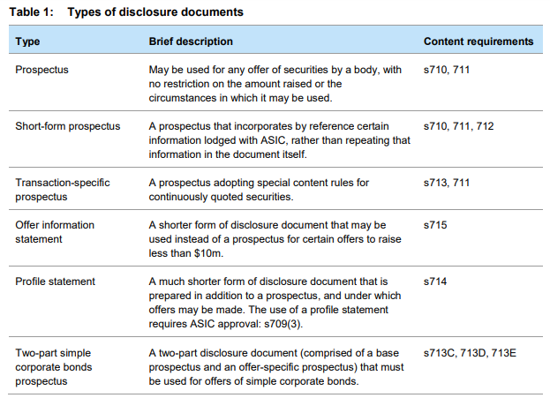
Disclosure is not required where the offer is made:
- To those who may be familiar with the affairs of that company—including ‘small scale offerings’ (20 issues or sales in 12 months)—and bonus issues, dividend reinvestment plans or offers of debentures to existing security holders. (s 708(1)–(7), (12)–(14)
- To sophisticated and professional investors, including where an Australian financial services (AFS) licensee considers the person to have sufficient previous experience. (s 708(8)–(11))
(refer: SOPHISTICATED AND WHOLESALE CLIENTS)
- For no consideration (s708(15) – (16))
- As part of another transaction that involves regulated disclosure and/or other measures to provide protection for investors, including under a takeover bid or scheme (see s708(17)– (18))
- By certain bodies, such as banks (for debentures only), exempt state bodies or public authorities. (see s708(19)–(21))
- That does not breach regulatory ceilings (s 708(1))

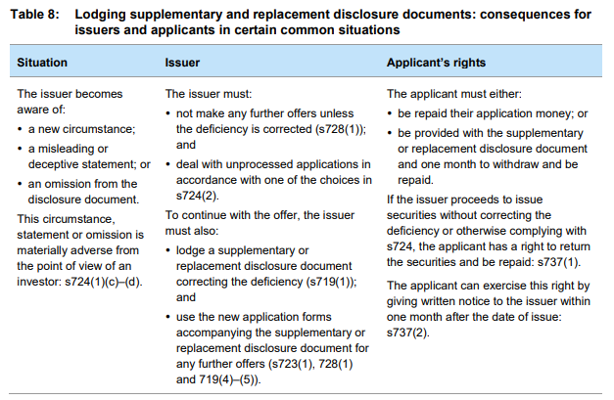

If an offer or intended offer of securities needs a disclosure document, a person must not:
- advertise the offer or intended offer; or
- publish a statement that:
  - directly or indirectly refers to the offer or intended offer; or
  - is reasonably likely to induce people to apply for the securities (s734(2)).

Interprac’s Operational Response
Education
Read in association with the section:
(refer: INTERPRAC’s BUSINESS PRINCIPLES: INVESTMENT)

SOPHISTICATED AND WHOLESALE CLIENTS
Regulatory Guidance
Sophisticated or Wholesale clients must be certified by a qualified accountant.
- ‘Sophisticated client’
- in the context of an offer of debt or shares (chapter 6D Corporations Act)

- ‘Wholesale client’
- in the context of an offer of other financial products (excepting insurance, superannuation, RSA) and the financial product is not used in connection with a business. (chapter 7 Corporations Act)
https://asic.gov.au/regulatory-resources/financial-services/financial-product-disclosure/certificates-issued-by-a-qualified-accountant/
ASIC’s Regulatory Guide “Guidance on ASIC market integrity rules for participants of securities markets” (RG 265) provides a definition:
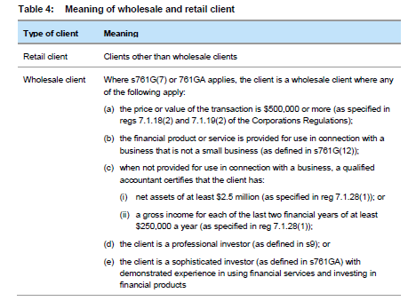
Sophisticated or Wholesale clients are exempt from certain disclosure requirements:
(refer: DISCLOSURE - SECURITIES)

Interprac’s Operational Response
Education
(refer: INTERPRAC’s BUSINESS PRINCIPLES: ADVICE TYPES)

PROVIDING TAX ADVICE
Regulatory Guidance
https://asic.gov.au/regulatory-resources/financial-services/financial-advisers-providing-tax-advice/
A tax (financial) advice service consists of five key elements:
- a tax agent service (excluding representations to the Commissioner of Taxation)
- provided by an Australian financial services (AFS) licensee or representative of an AFS licensee
- provided in the course of advice usually given by an AFS licensee or representative
- relates to ascertaining or advising about liabilities, obligations or entitlements that arise, or could arise, under a taxation law
- reasonably expected to be relied upon by the client for tax purposes.
(refer: TAX FINANCIAL ADVISERS)

Interprac’s Operational Response
CPD (TASA)
(refer: TAX FINANCIAL ADVISERS)

QUALIFICATIONS
(refer: INTERPRAC’s BUSINESS PRINCIPLES: TAX PRACTITIONERS BOARD)
(refer: INTERPRAC’s BUSINESS PRINCIPLES: ONBOARDING ADVISERS)

EDUCATION
(refer: INTERPRAC CPD POLICY)

TRANSACTION ONLY SERVICES
Regulatory Guidance
ASIC’s Regulatory Guide “Licensing: Financial Product Advice and Dealing” (RG 36) provides for documentation processing at the ‘direction’ of a client.
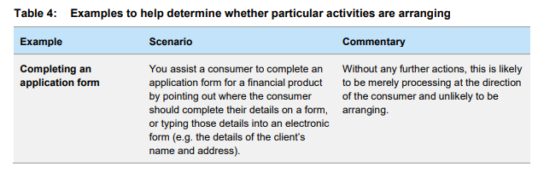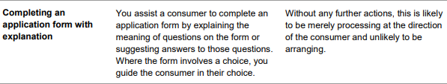
(refer: FINANCIAL PRODUCT ADVICE, DEALING AND ARRANGING)

Interprac’s Operational Response
LICENSEE MINIMUM DOCUMENTATION REQUIREMENTS
FSG, AML/CTF, Transaction Implementation Documentation, Comprehensive File-note
(refer: INTERPRAC’s ‘DEMONSTRATING BEST INTEREST IN THE SoA’ Guidelines Document)

Education
(refer: INTERPRAC’s BUSINESS PRINCIPLES: ADVICE TYPES)
(refer: INTERPRAC’s BUSINESS PRINCIPLES: ADVICE DOCUMENTATION)
(refer: INTERPRAC’s BUSINESS PRINCIPLES: ADVICE PROCESS)

