Appendix Text

AusPrac
AusPrac stands for Australian Practical Superannuation.

It is a sub-plan (Division II) of The MAP Master Superannuation Plan. The Trustee of the Fund is Diversa Trustees Limited; the Sponsor and Promoter is OneVue Wealth. Sequoia Asset Management Pty Ltd is the appointed Sub Promoter of Australian Practical Superannuation.

Account options
• Accumulation Account which applies during your working life,
• Transition to Retirement Pension Account where in certain circumstances you can draw some of your super while you are still working, and
• Pension Account where you can enjoy a pension income after you have reached your preservation age and have permanently retired.

AusPrac can help you find lost super, rollover super from your existing super fund or consolidate multiple super accounts

INVESTMENT

AusPrac offers a wide range of investments including pre-mixed Pooled Investments, and Super Wrap Investment Options including the Cash Hub, Managed Funds, Managed Account Model Portfolios and ASX Listed Securities, available through the OneVue Managed Account and Term Deposits.

Investment Menu
AusPrac offers a Core Menu and a Full Menu which offer different investments and have different administration fees.

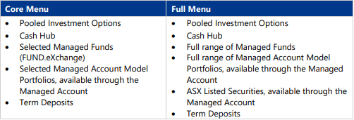
You can choose one investment option or a combination of different investment options as part of the online application process.

Cash Hub
The Cash Hub, is available in both the Core Menu and the Full Menu for both Accumulation and Pension Accounts and is an interest-bearing transaction account which holds your available cash for investment. The Cash Hub is also used to receive income and distributions from the fund and pay fees, costs, tax and other deductions.
If you choose to invest only in Pooled Investment Options, you are not required to have a Cash Hub, but you may choose to do so. If you invest in Super Wrap Investment Options, you must maintain at least $2,500 in your Cash Hub plus:
• three-months’ pension payments if you have a Pension Account, or
• three-months’ insurance premium payments if you have Group or Retail Insurance in place.

INSURANCE

AusPrac offers Group Insurance (including default cover and voluntary cover) and Retail Insurance covering Death, Total and Permanent Disability (TPD) and Income Protection. You can pay your insurance premiums out of your superannuation.

You’re able to opt out of cover, opt-in to cover, transfer existing cover, or vary your cover. Limited cover, exclusions and other conditions may apply.

Types of cover
You can access insurance cover through AusPrac to help protect your family’s financial security against the unexpected. Both Group Life insurance (default cover and voluntary cover) and Retail Insurance cover are available in Australian Practical Superannuation.
Retail Insurance terms are specific to the retail insurer’s product disclosure statement. Speak to your financial adviser to obtain a copy of an insurer’s product disclosure statement or to apply for Retail Insurance cover.

Options available for Retail Insurance cover:
• Death insurance provides a lump sum benefit in the event of death, or if you are diagnosed with a Terminal Illness. TPD Insurance provides a lump sum benefit if you suffer a TPD, and
• Income Protection pays a set percentage of your monthly income for a pre-defined length of time in the event that you suffer total disability as a result of illness or injury.

Group Insurance cover options are:
• Death insurance provides a lump sum benefit in the event of death, or if you are diagnosed with a Terminal Illness, and
• TPD Insurance provides a lump sum benefit if you suffer a Total and Permanent Disablement.

Your insurance cover will not commence until your first contribution or rollover has been received, an insurance premium is paid out of your Accumulation Account, and confirmation of the insurance cover has been provided.
Default insurance cover is limited for the first twenty-four months of your membership. Any pre-existing illness or injuries are not covered during this time. Refer to the Australian Practical Superannuation Insurance Guide for further information on new events cover.

Types of Group Life Insurance
Australian Practical Superannuation offers two types of default Group Insurance cover – personal and employee, and voluntary cover, which is subject to underwriting. The type of default insurance cover available to you is determined by your employment status.

RISKS & BENEFITS

Benefits
The Secure Online Portal provides online access to:
• check your balance,
• obtain BPAY contribution information,
• view your contributions and Account transactions,
• view and vary your pension payments,
• vary your Group Life Insurance, and
• view and download various reports

Risks
All investments carry risk. Super funds may invest in a range of asset classes – for example, cash, fixed interest, property and shares – that have different levels of risks. The likely investment return, and the risk of losing money is different for each investment option depending on the assets that make up the investment strategy.
Generally, the highest long-term returns may also carry the highest level of short-term risk.

It is important to understand and consider the investment risks in super before you invest:
• the value of the investment will go up and down,
• the level of returns will vary, and future returns may differ from past returns,
• returns are not guaranteed and you may lose some of your money,
• the amount of your future superannuation savings (including contributions and returns) may not be enough to provide adequately for your retirement,
• laws affecting your super and pension may change in the future, and
• the level of risk for you will vary depending on a range of factors including your age, your investment timeframes, where other parts of your wealth are invested and your risk tolerance.

Other risks
Other risks associated with investing in Australian Practical Superannuation include:

• Capital risk
• Market risk
• Inflation risk
• Settlement risk
• Interest rate risk
• Exchange rate risk
• Derivatives risk
• Fund risk
• Operational risk
• Legal and Regulatory risk
• Credit risk
• Investment management risk
• Country/Emerging markets risk
• Valuation risk
• Leverage risk
• Borrowing risk
• Liquidity risk
• Longevity risk

FEES & COSTS
Entry fees and exit fees cannot be charged.

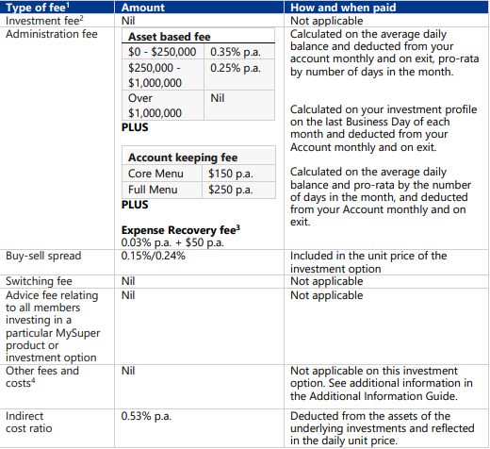

1 If your Account balance for a product offered by the superannuation entity is less than $6,000 at the end of the entity’s income year, the total combined amount of the administration fees, investment fees and indirect costs charged to you is capped at 3% of the account balance. Any amount charged in excess of that cap must be refunded.
2 Underlying fees may be charged by the fund manager, investment manager or the product provider.
3 Expense recovery fee is paid into a reserve and may include transfers to Operational Risk Finance Reserve (ORFR) from member accounts if required to meet regulatory requirements. Subject to 1 above, the fee of $50 applies irrespective of your Account balance.
4 Depending on the investment option you choose; other fees and costs may apply. Refer to the Additional Information Guide. Also refer to the Additional explanation of fees and costs.

How fees and costs are charged
Fees and costs can be paid directly from your Cash Hub or deducted from your investment returns.

Changes to fees and costs
The Trustee may introduce new fees or change existing fees at any time. They will notify you at least 30 days in advance before they introduce new fees, if the changes are materially adverse to you, or if they increase existing fees.

Fees and Costs of underlying investments
For Super Wrap investments in Managed Funds, in the Managed Account Model Portfolios and ASX Listed Securities available in the Managed Account, underlying fees may be charged by the fund manager, portfolio investment manager or the product provider, as applicable. These fees and costs are in addition to the fees and costs you pay in Australian Practical Superannuation. For details of the fees and cost that apply to the particular investment, you should refer to the product disclosure statement for that investment, available in the Secure Online Portal.

COOLING-OFF PERIOD
If you change your mind after opening an Account, you can write to AusPrac to cancel your application within your 14-day cooling-off period. Your cooling-off period starts at the earlier of:

• 5 days after your application is accepted, or
• the date the Fund confirms your membership in writing.

Upon cancellation, AusPrac will refund any contributions you have made to your Account (if you are entitled to access your super) or transfer any contributions you have made to a nominated complying super fund. The refund may be decreased or increased to allow for market movements of your investments during that time. AusPrac may also deduct any reasonable transaction and administrative costs, tax or duty incurred. Fees you have agreed to pay your financial adviser may also be deducted.

